# Traffic Congestion Prediction

# Using Deep Learning

# (Bi-directional LSTM)

Summer Internship-1 Report Submitted in partial fulfillment of the requirement for undergraduate degree of

### Bachelor of Technology

In

## COMPUTER SCIENCE AND ENGINEERING

By

### KRISHNA VARMA VETUKURI

### HU21CSEN0300138

Under the Guidance of **Mr. T. Sasi Vardhan** Assistant Professor



Department Of Computer Science and Engineering GITAM School of Technology

GITAM (Deemed to be University) Hyderabad-502329

December2023

# DECLARATION

I submit this Internship-1 work entitled “**Traffic Congestion Prediction Using Deep Learning**” to GITAM (Deemed To Be University), Hyderabad in partial fulfilment of the requirements for the award of the degree of “**Bachelor of Technology**” in “**Computer Science and Engineering**”. I declare that it was carried out independently by me under the guidance of **Mr.T. Sasi Vardhan**, Asst. Professor, GITAM (Deemed To Be University), Hyderabad, India.

The results embodied in this report have not been submitted to any other University or Institute for the award of any degree or diploma.

Place: HYDERABAD Name: KRISHNA VARMA VETUKURI

Date:19-12-2023 Student Roll No: HU21CSEN0300138

# ACKNOWLEDGEMENT

Apart from my effort, the success of this Internship-1 largely depends on the encouragement and guidance of many others. I take this opportunity to express my gratitude to the people who have helped me in the successful competition of this Internship-1.

I would like to thank respected **Prof. D. Sambasiva Rao**, Pro Vice Chancellor, GITAM Hyderabad, and **Dr. N. Seetharamaiah**, Associate Director, GITAM Hyderabad.

I would like to thank respected **Dr. Mahaboob Shaik Basha,** Head of the Computer Science and Engineering for giving me such a wonderful opportunity to expand my knowledge for my own branch and giving me guidelines to present an Internship-1 report. It helped me a lot to realize of what we study for.

I would like to thank the respected faculties **Mr. T.Sasi Vardhan** who helped me to make this Internship-1 a successful accomplishment.

I would also like to thank my friends who helped me to make my work more organized and well-stacked till the end.

Name: KRISHNA VARMA VETUKURI

Pin: HU21CSEN0300138

# ABSTRACT

This project focuses on predicting potential traffic congestion at signalized intersections during peak hours, aiming to provide road travelers with advance information to avoid congested signals if alternative routes are available. The prediction is based on a dataset of traffic flow, utilizing the Bi-Directional Long Short-Term Memory (LSTM) neural network architecture.

The project comprises four modules. The first module involves storing traffic details in a database, while the second module focuses on storing junction details and verifying dataset existence in the project folder. The third module generates a Bi-Directional LSTM graph using existing data, and the fourth module produces a graph using predicted data.

Long Short-Term Memory (LSTM) is an artificial neural network architecture specifically designed for processing and predicting time series data. Unlike traditional feedforward networks, LSTMs have feedback connections, consisting of a cell, input gate, output gate, and forget gate. LSTMs excel in handling time series data due to their ability to capture information over arbitrary time intervals, making them suitable for predicting traffic flow.

Python modules such as TensorFlow and Keras are employed, and the project outputs include Junction SQL entities with data, Traffic SQL entities with data, Bi-Directional LSTM graphical plots of existing data, and Bi-Directional LSTM graphical plots of predicted data.

In the existing system, the traffic department reacts to congestion by diverting traffic when signals are clogged. The proposed system seeks to predict congestion in advance, allowing for proactive traffic diversions before congestion occurs.

This predictive approach aims to enhance traffic management and improve overall road efficiency.

**Tools Used:** TensorFlow, Keras, SQL (Structured Query Language)

**Algorithms Used:** Bi-Directional Long Short-Term Memory (LSTM

**TABLE OF CONTENTS**

**CHAPTER 1: INTRODUCTION....................................................4**

1.1. Introduction...............................................................................................4

1.2. Problem Definition....................................................................................4

1.3. Objectives..................................................................................................4

1.4. Advantages................................................................................................4

**CHAPTER 2: REQUIREMENTS ANALYSIS..............................5**

2.1. Requirements.............................................................................................5

2.2. Feasibility Analysis...................................................................................5

**CHAPTER 3: SYSTEM DESIGN...................................................6**

3.1. Architecture Design..................................................................................6

3.2. Data Flow Diagram...................................................................................7

3.3. UML Diagrams.........................................................................................8

3.3.1. Use Case Diagram.............................................................................8

3.3.2. Sequence Diagram.............................................................................9

3.3.3. Activity Diagram..............................................................................10

3.4. Algorithm (Bi-Directional LSTM)..........................................................11

**CHAPTER 4: IMPLEMENTATION............................................12**

4.1. Python Packages......................................................................................12

4.1.1. Tensorflow........................................................................................12

4.1.2. Pandas...............................................................................................12

4.1.3. Numpy..............................................................................................12

4.1.4. PyQt5................................................................................................12

4.1.5. Sqlite3...............................................................................................12

4.1.6. Sys.....................................................................................................12

4.1.7. Os......................................................................................................13

4.2. Dataset.....................................................................................................13

4.3. Front End.................................................................................................14

**CHAPTER 5: CODING AND TESTING.....................................27**

5.1. Junction Details.......................................................................................28

5.2. Traffic Details.........................................................................................30

5.3. Data File Existence Verification.............................................................33

5.4. Bi-Directional LSTM..............................................................................34

5.5. Admin Operations...................................................................................41

5.6. Generate Backup CSVs from DB Tables……….……………………..42

5.7. Generate Backup Trafficset CSV from DB Tables……………………43

5.8. Load Backup CSVs to DB Junction Table..............................................44

5.9. Load Backup CSVs to DB Traffic Details Table.……………………..45

5.10. Load Initial Trafficset CSV to Traffic Details Table………………...47

**CHAPTER 6: CONCLUSION AND FUTURE SCOPE.............49**

6.1. Conclusion...............................................................................................49

6.2. Future Scope............................................................................................49

**CHAPTER 7: REFERENCES….................................................. 49**

**LIST OF FIGURES**

Figure 01. Architecture Design.................................................................................6

Figure 02. Data Flow Diagram..................................................................................7

Figure 03. File Directory all Files.............................................................................7

Figure 04. USE CASE DIAGRAM...........................................................................8

Figure 05. SEQUENCE DIAGRAM.........................................................................9

Figure 06. ACTIVITY DIAGRAM.........................................................................10

Figure 07. Bi-Direction LSTM................................................................................11

Figure 08. Congest.ui...............................................................................................14

Figure 09. junction.ui...............................................................................................16

Figure 10. traffic.ui..................................................................................................19

Figure 11. file_existance.ui.....................................................................................23

Figure 12. adminOps.ui...........................................................................................24

Figure 13. congest1.py............................................................................................27

Figure 14. Junction Details Filling..........................................................................30

Figure 15. jndtls DB Table......................................................................................30

Figure 16. Traffic Details Filling............................................................................32

Figure 17. trfcdtls DB Table...................................................................................32

Figure 18. file_existance1.py..................................................................................34

Figure 19. file_existance1.py output.......................................................................34

Figure 20. Plot Loss and RMSE loss vs Epochs.....................................................39

Figure 21. LSTM Plot of Existing Data..................................................................40

Figure 22. LSTM Plot of Predicted Data................................................................40

Figure 23. LSTM Plot of Existing with Predicted Data..........................................40

Figure 24. Admin Operation Buttons......................................................................42

Figure 25. General Backup CSVs from DB Table cmd..........................................43

Figure 26. General Backup CSVs in file.................................................................43

Figure 27. Generate Backup Trafficset CSV...........................................................44

Figure 28. Generate Backup Trafficset CSV in file................................................44

Figure 29. Load Backup CSVs to DB Junction Table.............................................45

Figure 30. Load Backup CSVs to DB Traffic Table...............................................46

Figure 31. Load Initial Trafficset CSV to Traffic Details Table.……….………...48

**CHAPTER 1: INTRODUCTION**

* 1. **Introduction:**

In our ever-growing urban landscapes, traffic congestion has become a pervasive issue, causing frustration and inconvenience for commuters. To address this challenge, our project delves into the realm of traffic congestion prediction. By harnessing the power of advanced technologies like Bi-Directional Long Short-Term Memory (LSTM) neural networks, we aim to foresee potential congestion at signalized intersections during peak hours.

* 1. **Problem Definition:**

**Vision:**

The project aims at developing a tool for Traffic Congestion Prediction using Deep Learning, with all the above mentioned advantages.

**Mission:**

This tool is developed by using Python along with its TensorFlow and Keras modules.

* 1. **Objectives:**
* Help traffic control guide traffic away from busy signals.
* Give travelers timely info to avoid traffic jams and make roads work better.
* Show real-time tips to cut travel time by avoiding crowded signals.
* Make road trips better for everyone.
* Use smart predictions for traffic using advanced tech like LSTM, Python, TensorFlow, and Keras.
* Use Python for strong features and simple code that works well.
  1. **Advantages:**
* This project proves invaluable for traffic control departments, guiding traffic towards signals with minimal congestion. For road travelers, it becomes a handy tool to slash travel time by sidestepping signal bottlenecks. Ultimately, the project contributes to an elevated quality of road travel experience.
* In the tech realm, we leverage cutting-edge Python tools like TensorFlow and Keras to implement the powerful LSTM. Embracing Python as our programming language of choice, acclaimed by the programming community, allows us to achieve more functionality with concise and efficient code.

**CHAPTER 2: SYSTEM REQUIREMENTS**

**2.1 Requirement Analysis**

**2.1.1 Hardware Requirements**

1. It requires a minimum of 2.16 GHz processor.
2. It requires a minimum of 4 GB RAM.
3. It requires 64-bit architecture.
4. It requires a minimum storage of 500GB.

**2.1.2 Software Requirements**

1. It requires a 64-bit Windows Operating System.
2. Python Qt Designer for designing user interface.
3. Pyuic for converting the layout designed user interface (UI) to python code.
4. Python language for coding.

**2.2 Feasibility Analysis**

Feasibility analysis is like a reality check for an idea. It helps determine if a project is viable from legal, technical, and financial perspectives. The study assesses if a project is a wise investment; however, there are instances where it may not be. This could be due to the excessive requirements, such as time and money, that might not yield sufficient profit. It's essentially the process of deciding if something is achievable or simply not worthwhile.

**2.2.1 Economic Feasibility**

Economic feasibility is like checking if a project is worth the money. It involves looking at the costs and benefits before spending any money. This helps organizations decide if a project is a good idea financially. It also makes the project look more trustworthy because decision-makers can see the positive economic benefits it brings. Our project is financially doable because we used open-source tools like "UBUNTU," "PYTHON," "PYQT" designer tool, and "PYUIC," which means they didn't cost us anything.

**2.2.2 Technical Feasibility**

Technical feasibility is about checking if a project can work with the tech stuff the organization has. It helps see if the technical resources, like computers and software, are good enough. We also made a sample of our tool to make sure it works with the tech we have. The sample is doing well, so our project is technically doable.

**CHAPTER 3: SYSTEM DESIGN**

**3.1 Architecture Design**

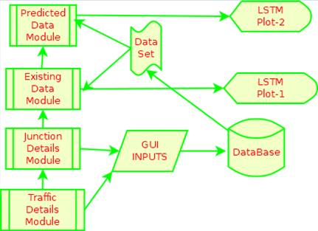

**Figure 1. Architecture Design**  
The architectural framework comprises four key modules:

1. **Traffic Details Storage:**
   * **Objective:** Store traffic details in the database.
   * **Functionality:** Handles the collection and storage of traffic-related information.
2. **Junction Details Management:**
   * **Objective:** Store junction details in the database and verify the existence of the dataset in the project folder.
   * **Functionality:** Manages the storage of junction-specific data and ensures dataset integrity.
3. **Bi-Directional LSTM Graph Generation (Existing Data):**
   * **Objective:** Generate a Bi-Directional LSTM graph using the existing traffic data.
   * **Functionality:** Involves processing historical data to create a graphical representation of traffic patterns.
4. **Bi-Directional LSTM Graph Generation (Predicted Data):**
   * **Objective:** Generate a Bi-Directional LSTM graph using predicted traffic data.
   * **Functionality:** Utilizes advanced modeling techniques to predict future traffic patterns and visualizes them in a graph.

**3.2 Data Flow Diagram**

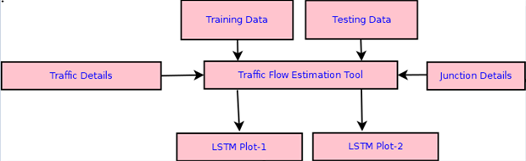

**Figure 2. Data Flow Diagram**

**Screen shots and descriptions:**

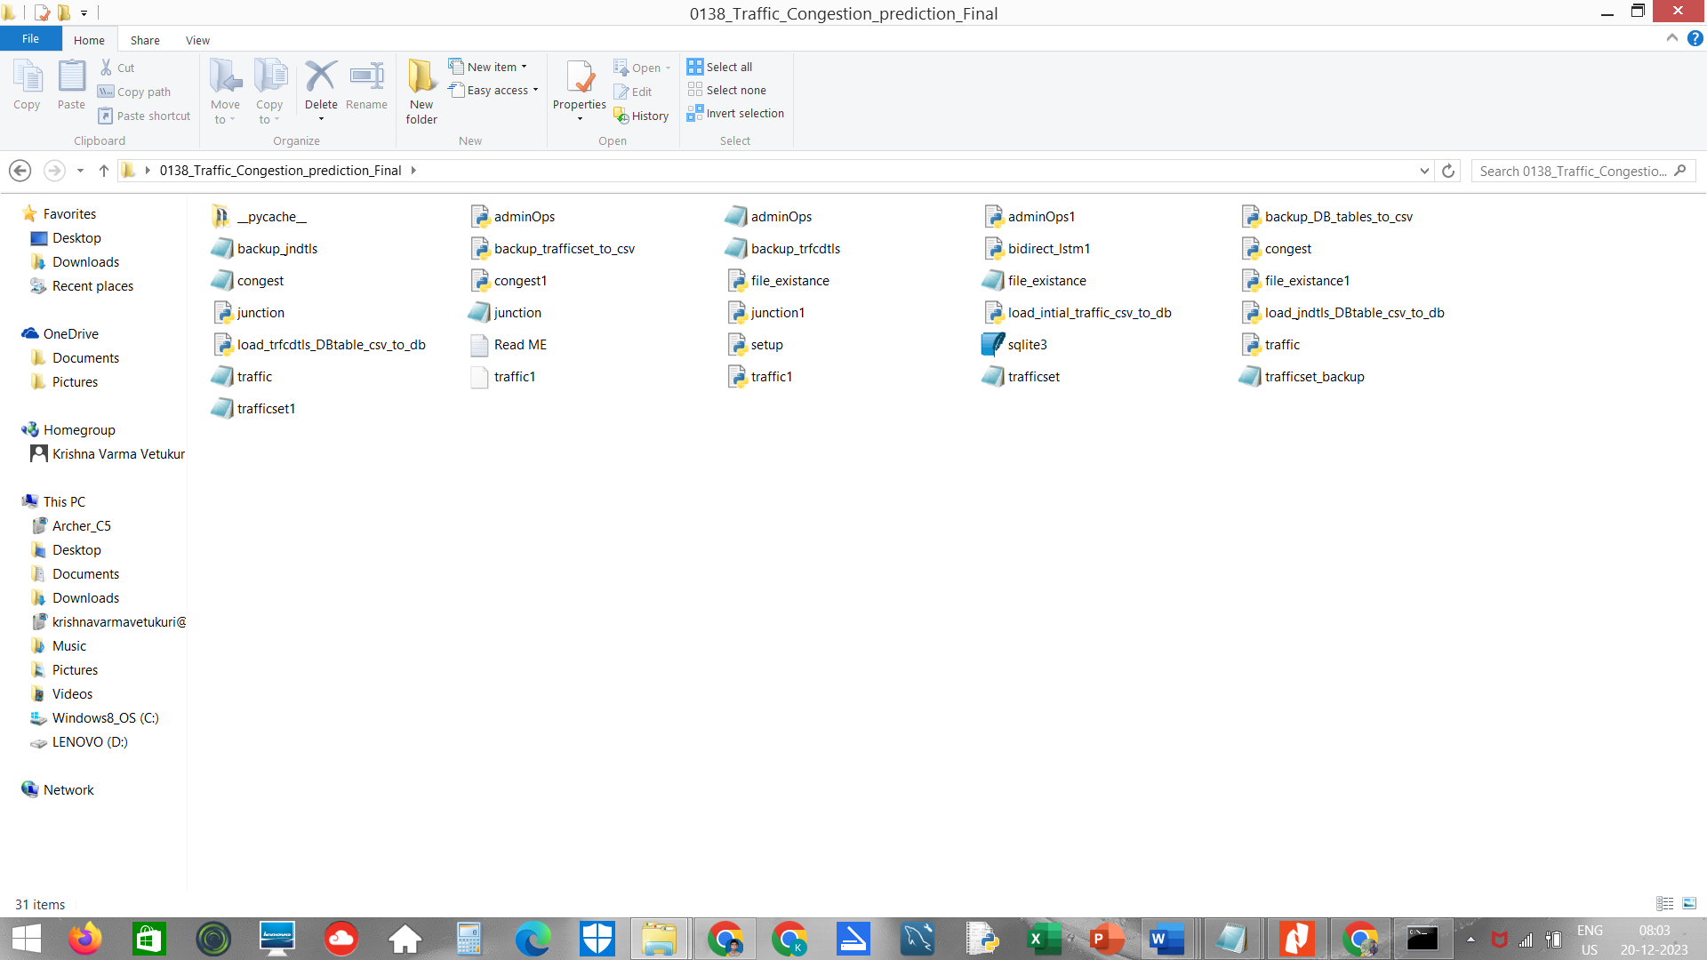

**Figure 3. File Directory all Files**

The screenshot displays various files generated throughout the project, categorized into three types:

(1) .py files, representing Python program files,

(2) .ui files, serving as user interface files crafted using PyQt layout editor, and

(3) .txt files, containing general project information.

Notably, each .ui file is accompanied by an automatically generated .py file, produced using the PyUIC tool.

The .txt files store essential, generic project details.

* 1. **UML DIAGRAMS**
     1. **Use Case Diagram**

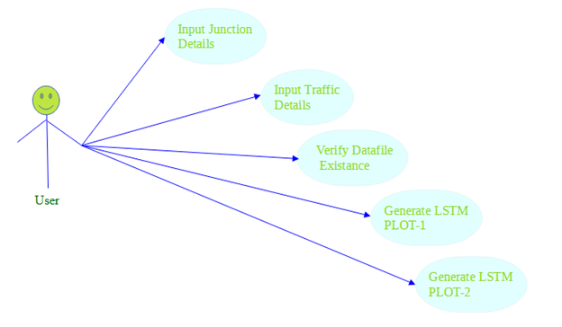

**Figure 4. USE CASE DIAGRAM**

**Description of Use case diagram**

A use case diagram is like a map showing how users and a system work together. It describes the actions (use cases) a system can do with the help of external users (actors). In our case, the user interacts with the system by installing and importing tools like TensorFlow and Keras. They also provide the traffic dataset, start the LSTM processes, and get plots for both existing and predicted data. It's a simple representation of how the user and the system connect through different actions.

* + 1. **Sequence diagram**

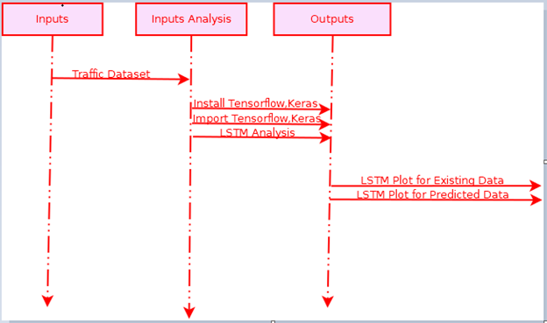

**Figure 5. SEQUENCE DIAGRAM**

**Description of sequence diagram**

A sequence diagram is like a step-by-step guide showing how things work together. In our case, it guides us through these steps: first, provide the traffic dataset; next, import tools like TensorFlow and Keras; then, start the LSTM processes, and finally, create the required plots for both existing and predicted data. It's a clear way of understanding the order of actions between different parts of the system.

* + 1. **ACTIVITY DIAGRAM**

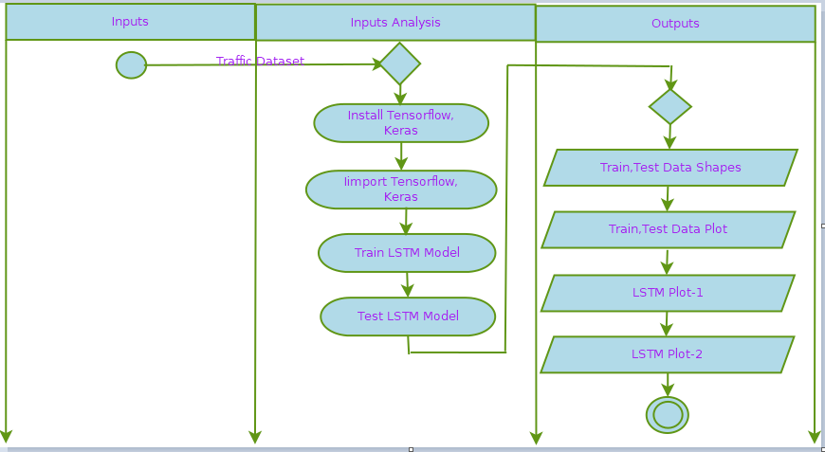

**Figure 6. ACTIVITY DIAGRAM**

**Description of Activity diagram**

An activity diagram is like a flow chart showing how different actions happen in a system. In our case, the flow starts with providing the traffic dataset, then moves to importing tools like TensorFlow and Keras. After that, it goes to initiating the LSTM processes and ends with generating the plots for both existing and predicted data. It's a visual way of understanding the order of operations in the system.

* 1. **Algorithm (Bi-Directional LSTM)**
* Bi-Directional LSTM (Bidirectional Long Short-Term Memory) is a supervised learning algorithm used for sequence prediction tasks, particularly in predicting traffic flow patterns.
* It belongs to the category of recurrent neural networks (RNNs), specifically designed for processing sequential or time-series data.
* Bi-LSTM processes sequences in both forward and backward directions, combining LSTM's capabilities with bidirectional modeling.
* The bidirectional nature enhances the algorithm's effectiveness in understanding and predicting temporal patterns, making it well-suited for applications such as traffic flow prediction.

**Importance:**

The significance of using Bi-Directional LSTM lies in its capacity to comprehend and predict sequences in both forward and backward directions. This capability proves essential for tasks involving time-dependent data, such as predicting traffic congestion, where understanding historical and future patterns is crucial for accurate forecasts.

**Applications:**

**Traffic Prediction:** Predicting traffic congestion at signalized intersections, enabling proactive traffic management.

**Natural Language Processing:** Analyzing and predicting sequences in language data.

**Speech Recognition**: Understanding and predicting patterns in spoken language.

**Illustration:**

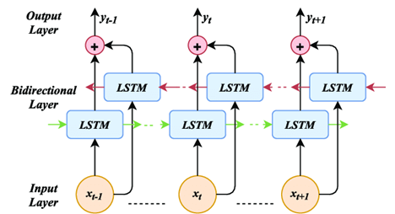

**Figure 7. Bi-Direction LSTM**

**CHAPTER 4: IMPLEMENTATION**

* 1. **Python Packages**
     1. **TensorFlow:**

TensorFlow is a popular open-source machine learning library used to build and train various types of deep learning models. It provides tools for tasks like neural network development and deployment, making it widely utilized in the field of artificial intelligence.

* + 1. **Pandas:**

Pandas is a powerful data manipulation library in Python. It offers easy-to-use data structures like DataFrames, making it efficient for tasks such as data cleaning, exploration, and analysis in data science projects.

* + 1. **Numpy:**

Numpy is a fundamental package for numerical computing in Python. It provides support for large, multi-dimensional arrays and matrices, along with mathematical functions to operate on these arrays, making it essential for scientific computing tasks.

* + 1. **PyQt5:**

PyQt5 is a set of Python bindings for Qt, a popular graphical user interface (GUI) toolkit. It enables the creation of interactive and visually appealing desktop applications with ease.

* + 1. **Sqlite3:**

Sqlite3 is a lightweight, embedded relational database management system included with Python. It allows for easy implementation and management of small to medium-sized databases within applications.

* + 1. **Sys:**

Sys is a built-in Python module providing access to some variables used or maintained by the Python interpreter and functions that interact strongly with the interpreter. It is often used for system-related operations and accessing command-line arguments.

* + 1. **Os:**

Os is another built-in Python module that provides a way of using operating system-dependent functionality, such as reading or writing to the file system. It simplifies tasks related to file and directory operations in a platform-independent manner.

* 1. **DATASET:**

The dataset, named "trafficset1.csv," comprises 14,951 rows, capturing traffic conditions at a particular junction over time intervals. Each row represents the traffic status for different directions and signals, with the following columns:

RD_tfc_N1i: Traffic in incoming North Road 1

RD_tfc_N1o: Traffic in outgoing North Road 1

RD_tfc_N2i: Traffic in incoming North Road 2

RD_tfc_N2o: Traffic in outgoing North Road 2

RD_tfc_S1i: Traffic in incoming South Road 1

RD_tfc_S1o: Traffic in outgoing South Road 1

RD_tfc_E1i: Traffic in incoming East Road 1

RD_tfc_E1o: Traffic in outgoing East Road 1

RD_tfc_W1i: Traffic in incoming West Road 1

RD_tfc_W1o: Traffic in outgoing West Road 1

RD_tfc_Total: Total traffic at the junction

The values represent different levels of traffic conditions:

0: No traffic or No signal & road in that direction

1: Very low traffic

2: Low traffic

3: Medium traffic

4: High traffic

5: Very high traffic

The dataset reflects the dynamic traffic conditions for each road and signal at a specific junction, providing insights into the road status over different time intervals

* 1. **FRONT END**

The front end of the application consists of several GUI screens, each designed with specific buttons and functionalities. The GUI screens are created using Qt Designer, a tool that facilitates GUI creation through a drag-and-drop approach.

The GUI screens are initially designed using Qt Designer, and later converted to Python code using the pyuic5 command. This approach eliminates the need for manual coding, making the GUI creation process more efficient.

By using the following command we can convert the GUI to python code

|  |
| --- |
| pyuic5 filename.ui -o filename.py |

In the project, the GUI screens were designed using Qt Designer, resulting in the following UI files:

1. **congest.ui**
2. **junction.ui**
3. **traffic.ui**
4. **file_existance.ui**
5. **adminOps.ui**

Upon utilizing the **pyuic5** command, the corresponding Python files are generated:

congest.py, junction.py, traffic.py, file_existance.py, adminOps.py from each .ui file respectively

**congest.ui**

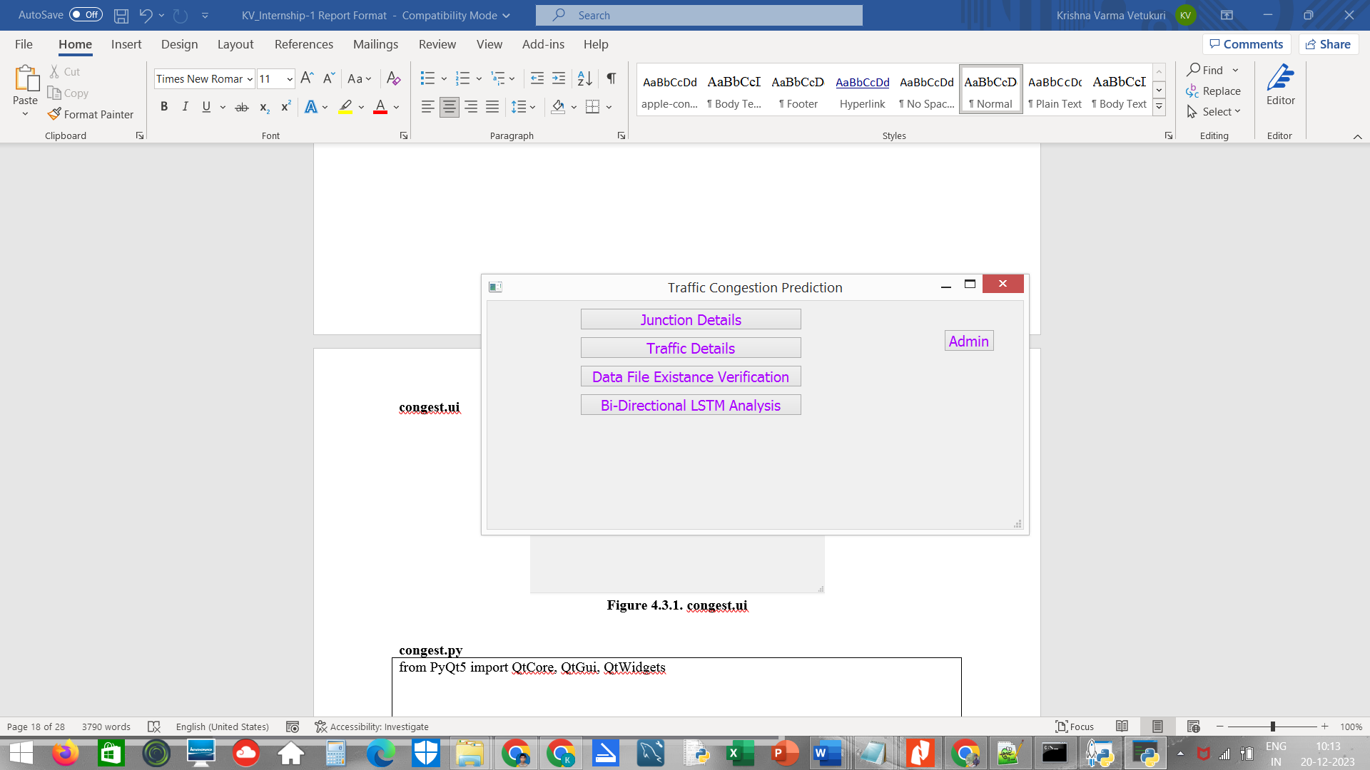

Figure 8. Congest.ui

**congest.py**

|  |
| --- |
| from PyQt5 import QtCore, QtGui, QtWidgets  class Ui_MainWindow(object):  def setupUi(self, MainWindow):  MainWindow.setObjectName("MainWindow")  MainWindow.resize(587, 320)  MainWindow.setStyleSheet("color: rgb(170, 0, 255);\n"  "font: 75 12pt \"MS Shell Dlg 2\";")  self.centralwidget = QtWidgets.QWidget(MainWindow)  self.centralwidget.setObjectName("centralwidget")  self.pushButton = QtWidgets.QPushButton(self.centralwidget)  self.pushButton.setGeometry(QtCore.QRect(130, 50, 311, 31))  self.pushButton.setObjectName("pushButton")  self.pushButton_2 = QtWidgets.QPushButton(self.centralwidget)  self.pushButton_2.setGeometry(QtCore.QRect(130, 90, 311, 31))  self.pushButton_2.setObjectName("pushButton_2")  self.pushButton_4 = QtWidgets.QPushButton(self.centralwidget)  self.pushButton_4.setGeometry(QtCore.QRect(130, 130, 311, 31))  self.pushButton_4.setObjectName("pushButton_4")  self.pushButton_5 = QtWidgets.QPushButton(self.centralwidget)  self.pushButton_5.setGeometry(QtCore.QRect(130, 10, 311, 31))  self.pushButton_5.setObjectName("pushButton_5")  self.pushButton_6 = QtWidgets.QPushButton(self.centralwidget)  self.pushButton_6.setGeometry(QtCore.QRect(640, 40, 71, 31))  self.pushButton_6.setObjectName("pushButton_6")  MainWindow.setCentralWidget(self.centralwidget)  self.statusbar = QtWidgets.QStatusBar(MainWindow)  self.statusbar.setObjectName("statusbar")  MainWindow.setStatusBar(self.statusbar)  self.retranslateUi(MainWindow)  QtCore.QMetaObject.connectSlotsByName(MainWindow)  def retranslateUi(self, MainWindow):  _translate = QtCore.QCoreApplication.translate  MainWindow.setWindowTitle(_translate("MainWindow", "Traffic Congestion Prediction"))  self.pushButton.setText(_translate("MainWindow", "Traffic Details"))  self.pushButton_2.setText(_translate("MainWindow", "Data File Existance Verification"))  self.pushButton_4.setText(_translate("MainWindow", "Bi-Directional LSTM Analysis"))  self.pushButton_5.setText(_translate("MainWindow", "Junction Details"))  self.pushButton_6.setText(_translate("MainWindow", "Admin"))  if __name__ == "__main__":  import sys  app = QtWidgets.QApplication(sys.argv)  MainWindow = QtWidgets.QMainWindow()  ui = Ui_MainWindow()  ui.setupUi(MainWindow)  MainWindow.show()  sys.exit(app.exec_()) |

**junction.ui**

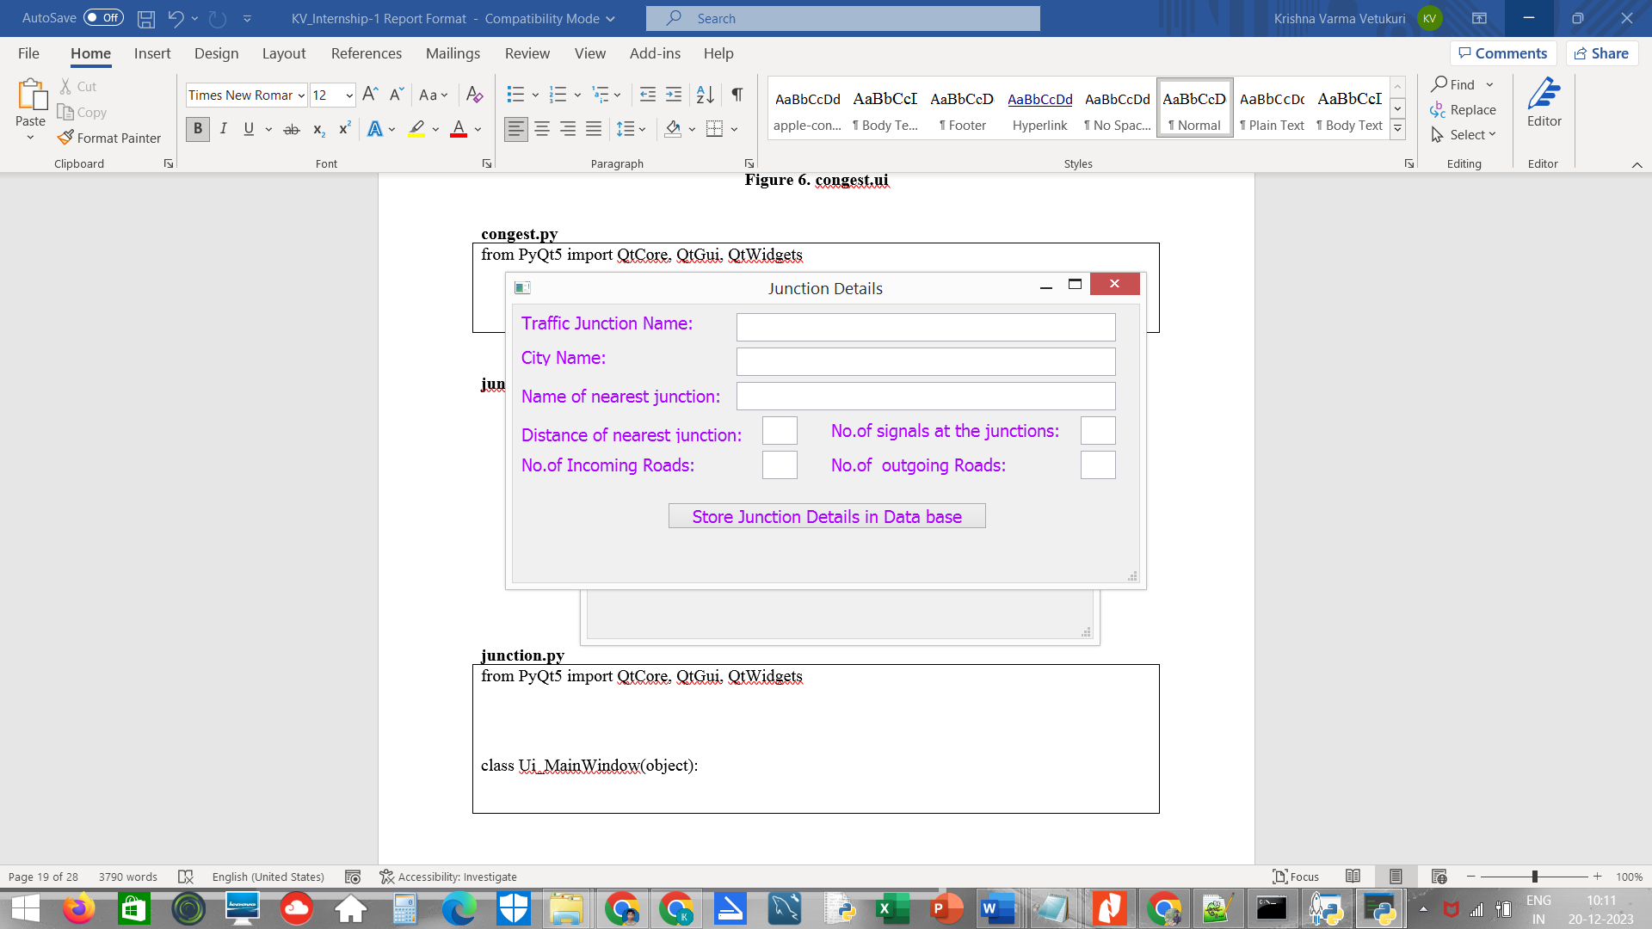

Figure 9. junction.ui

**junction.py**

|  |
| --- |
| from PyQt5 import QtCore, QtGui, QtWidgets  class Ui_MainWindow(object):  def setupUi(self, MainWindow):  MainWindow.setObjectName("MainWindow")  MainWindow.resize(728, 323)  MainWindow.setStyleSheet("color: rgb(170, 0, 255);\n"  "font: 75 12pt \"MS Shell Dlg 2\";")  self.centralwidget = QtWidgets.QWidget(MainWindow)  self.centralwidget.setObjectName("centralwidget")  self.pushButton = QtWidgets.QPushButton(self.centralwidget)  self.pushButton.setGeometry(QtCore.QRect(180, 230, 371, 31))  self.pushButton.setObjectName("pushButton")  self.lineEdit_4 = QtWidgets.QLineEdit(self.centralwidget)  self.lineEdit_4.setGeometry(QtCore.QRect(260, 50, 441, 33))  self.lineEdit_4.setObjectName("lineEdit_4")  self.label_4 = QtWidgets.QLabel(self.centralwidget)  self.label_4.setGeometry(QtCore.QRect(10, 50, 121, 21))  self.label_4.setObjectName("label_4")  self.lineEdit_5 = QtWidgets.QLineEdit(self.centralwidget)  self.lineEdit_5.setGeometry(QtCore.QRect(260, 90, 441, 33))  self.lineEdit_5.setObjectName("lineEdit_5")  self.lineEdit_6 = QtWidgets.QLineEdit(self.centralwidget)  self.lineEdit_6.setGeometry(QtCore.QRect(290, 130, 41, 33))  self.lineEdit_6.setObjectName("lineEdit_6")  self.lineEdit_7 = QtWidgets.QLineEdit(self.centralwidget)  self.lineEdit_7.setGeometry(QtCore.QRect(660, 130, 41, 33))  self.lineEdit_7.setObjectName("lineEdit_7")  self.lineEdit_8 = QtWidgets.QLineEdit(self.centralwidget)  self.lineEdit_8.setGeometry(QtCore.QRect(290, 170, 41, 33))  self.lineEdit_8.setObjectName("lineEdit_8")  self.label_6 = QtWidgets.QLabel(self.centralwidget)  self.label_6.setGeometry(QtCore.QRect(10, 90, 241, 31))  self.label_6.setObjectName("label_6")  self.label_7 = QtWidgets.QLabel(self.centralwidget)  self.label_7.setGeometry(QtCore.QRect(10, 140, 261, 21))  self.label_7.setObjectName("label_7")  self.label_8 = QtWidgets.QLabel(self.centralwidget)  self.label_8.setGeometry(QtCore.QRect(370, 130, 281, 31))  self.label_8.setObjectName("label_8")  self.label_9 = QtWidgets.QLabel(self.centralwidget)  self.label_9.setGeometry(QtCore.QRect(10, 170, 211, 31))  self.label_9.setObjectName("label_9")  self.label_5 = QtWidgets.QLabel(self.centralwidget)  self.label_5.setGeometry(QtCore.QRect(10, 10, 211, 21))  self.label_5.setObjectName("label_5")  self.lineEdit_9 = QtWidgets.QLineEdit(self.centralwidget)  self.lineEdit_9.setGeometry(QtCore.QRect(260, 10, 441, 33))  self.lineEdit_9.setObjectName("lineEdit_9")  self.label_10 = QtWidgets.QLabel(self.centralwidget)  self.label_10.setGeometry(QtCore.QRect(370, 170, 221, 31))  self.label_10.setObjectName("label_10")  self.lineEdit_10 = QtWidgets.QLineEdit(self.centralwidget)  self.lineEdit_10.setGeometry(QtCore.QRect(660, 170, 41, 33))  self.lineEdit_10.setText("")  self.lineEdit_10.setObjectName("lineEdit_10")  MainWindow.setCentralWidget(self.centralwidget)  self.statusbar = QtWidgets.QStatusBar(MainWindow)  self.statusbar.setObjectName("statusbar")  MainWindow.setStatusBar(self.statusbar)  self.retranslateUi(MainWindow)  QtCore.QMetaObject.connectSlotsByName(MainWindow)  def retranslateUi(self, MainWindow):  _translate = QtCore.QCoreApplication.translate  MainWindow.setWindowTitle(_translate("MainWindow", "Junction Details"))  self.pushButton.setText(_translate("MainWindow", "Store Junction Details in Data base"))  self.label_4.setText(_translate("MainWindow", "City Name:"))  self.label_6.setText(_translate("MainWindow", "Name of nearest junction:"))  self.label_7.setText(_translate("MainWindow", "Distance of nearest junction:"))  self.label_8.setText(_translate("MainWindow", "No.of signals at the junctions:"))  self.label_9.setText(_translate("MainWindow", "No.of Incoming Roads:"))  self.label_5.setText(_translate("MainWindow", "Traffic Junction Name:"))  self.label_10.setText(_translate("MainWindow", "No.of outgoing Roads:")) |

**traffic.ui**

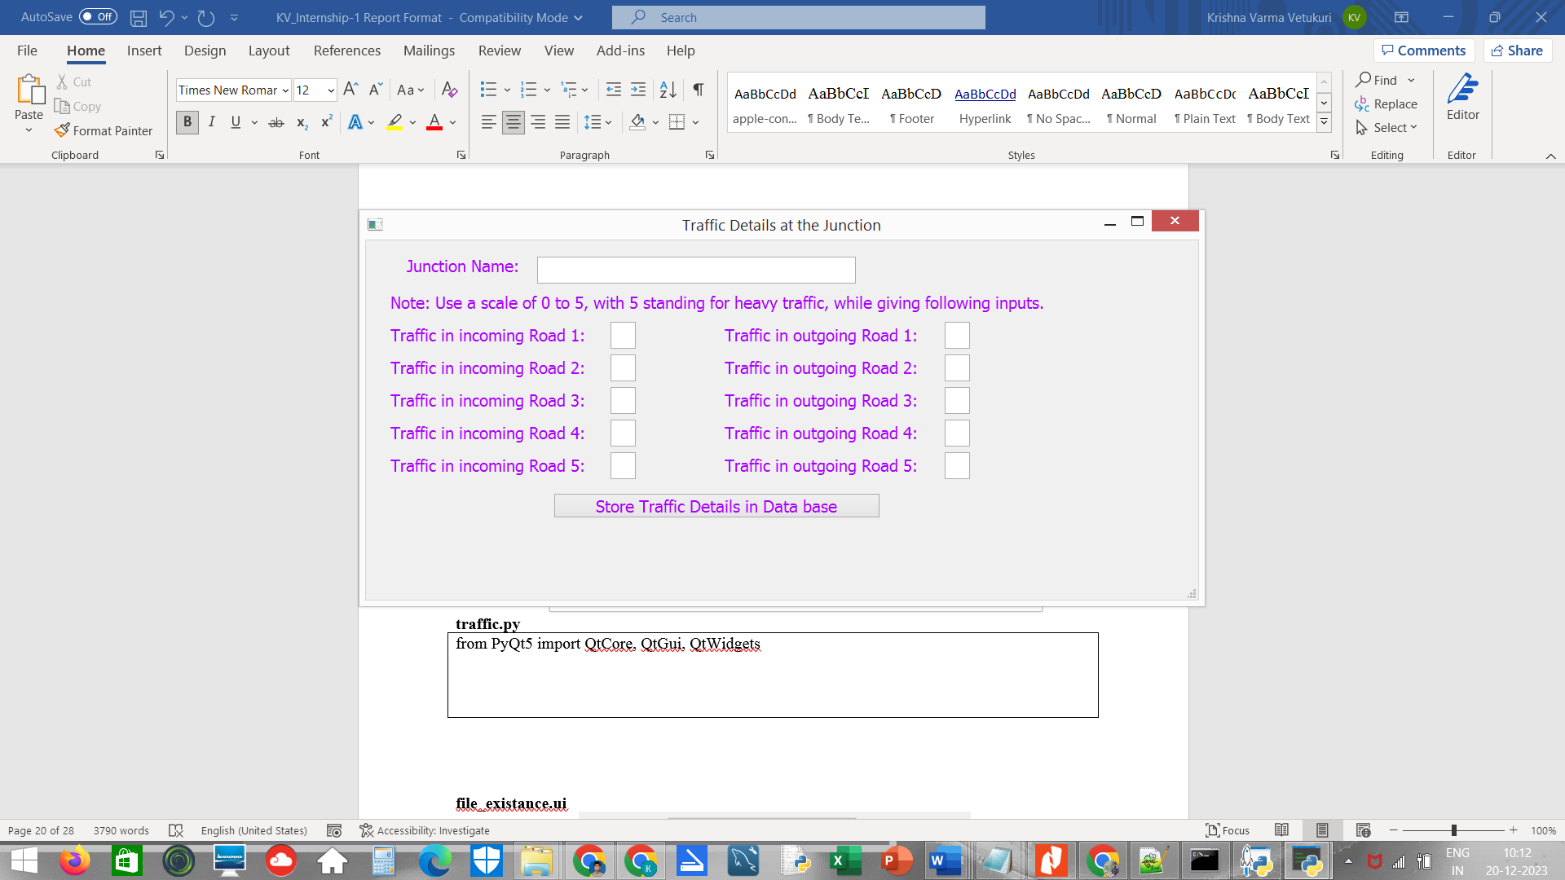

**Figure 10. traffic.ui**

**traffic.py**

|  |
| --- |
| from PyQt5 import QtCore, QtGui, QtWidgets  class Ui_MainWindow(object):  def setupUi(self, MainWindow):  MainWindow.setObjectName("MainWindow")  MainWindow.resize(1021, 441)  MainWindow.setStyleSheet("color: rgb(170, 0, 255);\n"  "font: 75 12pt \"MS Shell Dlg 2\";")  self.centralwidget = QtWidgets.QWidget(MainWindow)  self.centralwidget.setObjectName("centralwidget")  self.pushButton = QtWidgets.QPushButton(self.centralwidget)  self.pushButton.setGeometry(QtCore.QRect(230, 310, 401, 31))  self.pushButton.setObjectName("pushButton")  self.lineEdit_3 = QtWidgets.QLineEdit(self.centralwidget)  self.lineEdit_3.setGeometry(QtCore.QRect(300, 100, 31, 33))  self.lineEdit_3.setObjectName("lineEdit_3")  self.lineEdit_4 = QtWidgets.QLineEdit(self.centralwidget)  self.lineEdit_4.setGeometry(QtCore.QRect(300, 140, 31, 33))  self.lineEdit_4.setObjectName("lineEdit_4")  self.lineEdit_5 = QtWidgets.QLineEdit(self.centralwidget)  self.lineEdit_5.setGeometry(QtCore.QRect(300, 180, 31, 33))  self.lineEdit_5.setObjectName("lineEdit_5")  self.lineEdit_6 = QtWidgets.QLineEdit(self.centralwidget)  self.lineEdit_6.setGeometry(QtCore.QRect(300, 220, 31, 33))  self.lineEdit_6.setObjectName("lineEdit_6")  self.label_3 = QtWidgets.QLabel(self.centralwidget)  self.label_3.setGeometry(QtCore.QRect(30, 100, 251, 31))  self.label_3.setObjectName("label_3")  self.label_4 = QtWidgets.QLabel(self.centralwidget)  self.label_4.setGeometry(QtCore.QRect(30, 140, 241, 31))  self.label_4.setObjectName("label_4")  self.label_5 = QtWidgets.QLabel(self.centralwidget)  self.label_5.setGeometry(QtCore.QRect(30, 220, 241, 31))  self.label_5.setObjectName("label_5")  self.label_6 = QtWidgets.QLabel(self.centralwidget)  self.label_6.setGeometry(QtCore.QRect(30, 180, 241, 31))  self.label_6.setObjectName("label_6")  self.label_2 = QtWidgets.QLabel(self.centralwidget)  self.label_2.setGeometry(QtCore.QRect(30, 260, 241, 31))  self.label_2.setObjectName("label_2")  self.lineEdit_2 = QtWidgets.QLineEdit(self.centralwidget)  self.lineEdit_2.setGeometry(QtCore.QRect(300, 260, 31, 33))  self.lineEdit_2.setObjectName("lineEdit_2")  self.lineEdit_9 = QtWidgets.QLineEdit(self.centralwidget)  self.lineEdit_9.setGeometry(QtCore.QRect(210, 20, 391, 33))  self.lineEdit_9.setObjectName("lineEdit_9")  self.label_7 = QtWidgets.QLabel(self.centralwidget)  self.label_7.setGeometry(QtCore.QRect(50, 20, 151, 21))  self.label_7.setObjectName("label_7")  self.label_8 = QtWidgets.QLabel(self.centralwidget)  self.label_8.setGeometry(QtCore.QRect(30, 60, 821, 31))  self.label_8.setObjectName("label_8")  self.lineEdit_7 = QtWidgets.QLineEdit(self.centralwidget)  self.lineEdit_7.setGeometry(QtCore.QRect(710, 140, 31, 33))  self.lineEdit_7.setObjectName("lineEdit_7")  self.label_9 = QtWidgets.QLabel(self.centralwidget)  self.label_9.setGeometry(QtCore.QRect(440, 180, 241, 31))  self.label_9.setObjectName("label_9")  self.lineEdit_8 = QtWidgets.QLineEdit(self.centralwidget)  self.lineEdit_8.setGeometry(QtCore.QRect(710, 180, 31, 33))  self.lineEdit_8.setObjectName("lineEdit_8")  self.label_10 = QtWidgets.QLabel(self.centralwidget)  self.label_10.setGeometry(QtCore.QRect(440, 100, 251, 31))  self.label_10.setObjectName("label_10")  self.lineEdit_10 = QtWidgets.QLineEdit(self.centralwidget)  self.lineEdit_10.setGeometry(QtCore.QRect(710, 100, 31, 33))  self.lineEdit_10.setObjectName("lineEdit_10")  self.label_11 = QtWidgets.QLabel(self.centralwidget)  self.label_11.setGeometry(QtCore.QRect(440, 140, 241, 31))  self.label_11.setObjectName("label_11")  self.label_12 = QtWidgets.QLabel(self.centralwidget)  self.label_12.setGeometry(QtCore.QRect(440, 220, 241, 31))  self.label_12.setObjectName("label_12")  self.lineEdit_11 = QtWidgets.QLineEdit(self.centralwidget)  self.lineEdit_11.setGeometry(QtCore.QRect(710, 260, 31, 33))  self.lineEdit_11.setObjectName("lineEdit_11")  self.lineEdit_12 = QtWidgets.QLineEdit(self.centralwidget)  self.lineEdit_12.setGeometry(QtCore.QRect(710, 220, 31, 33))  self.lineEdit_12.setObjectName("lineEdit_12")  self.label_13 = QtWidgets.QLabel(self.centralwidget)  self.label_13.setGeometry(QtCore.QRect(440, 260, 241, 31))  self.label_13.setObjectName("label_13")  MainWindow.setCentralWidget(self.centralwidget)  self.statusbar = QtWidgets.QStatusBar(MainWindow)  self.statusbar.setObjectName("statusbar")  MainWindow.setStatusBar(self.statusbar)  self.retranslateUi(MainWindow)  QtCore.QMetaObject.connectSlotsByName(MainWindow)  def retranslateUi(self, MainWindow):  _translate = QtCore.QCoreApplication.translate  MainWindow.setWindowTitle(_translate("MainWindow", "Traffic Details at the Junction"))  self.pushButton.setText(_translate("MainWindow", "Store Traffic Details in Data base"))  self.label_3.setText(_translate("MainWindow", "Traffic in incoming Road 1:"))  self.label_4.setText(_translate("MainWindow", "Traffic in incoming Road 2:"))  self.label_5.setText(_translate("MainWindow", "Traffic in incoming Road 4:"))  self.label_6.setText(_translate("MainWindow", "Traffic in incoming Road 3:"))  self.label_2.setText(_translate("MainWindow", "Traffic in incoming Road 5:"))  self.label_7.setText(_translate("MainWindow", "Junction Name:"))  self.label_8.setText(_translate("MainWindow", "Note: Use a scale of 0 to 5, with 5 standing for heavy traffic, while giving following inputs."))  self.label_9.setText(_translate("MainWindow", "Traffic in outgoing Road 3:"))  self.label_10.setText(_translate("MainWindow", "Traffic in outgoing Road 1:"))  self.label_11.setText(_translate("MainWindow", "Traffic in outgoing Road 2:"))  self.label_12.setText(_translate("MainWindow", "Traffic in outgoing Road 4:"))  self.label_13.setText(_translate("MainWindow", "Traffic in outgoing Road 5:")) |

**file_existance.ui**

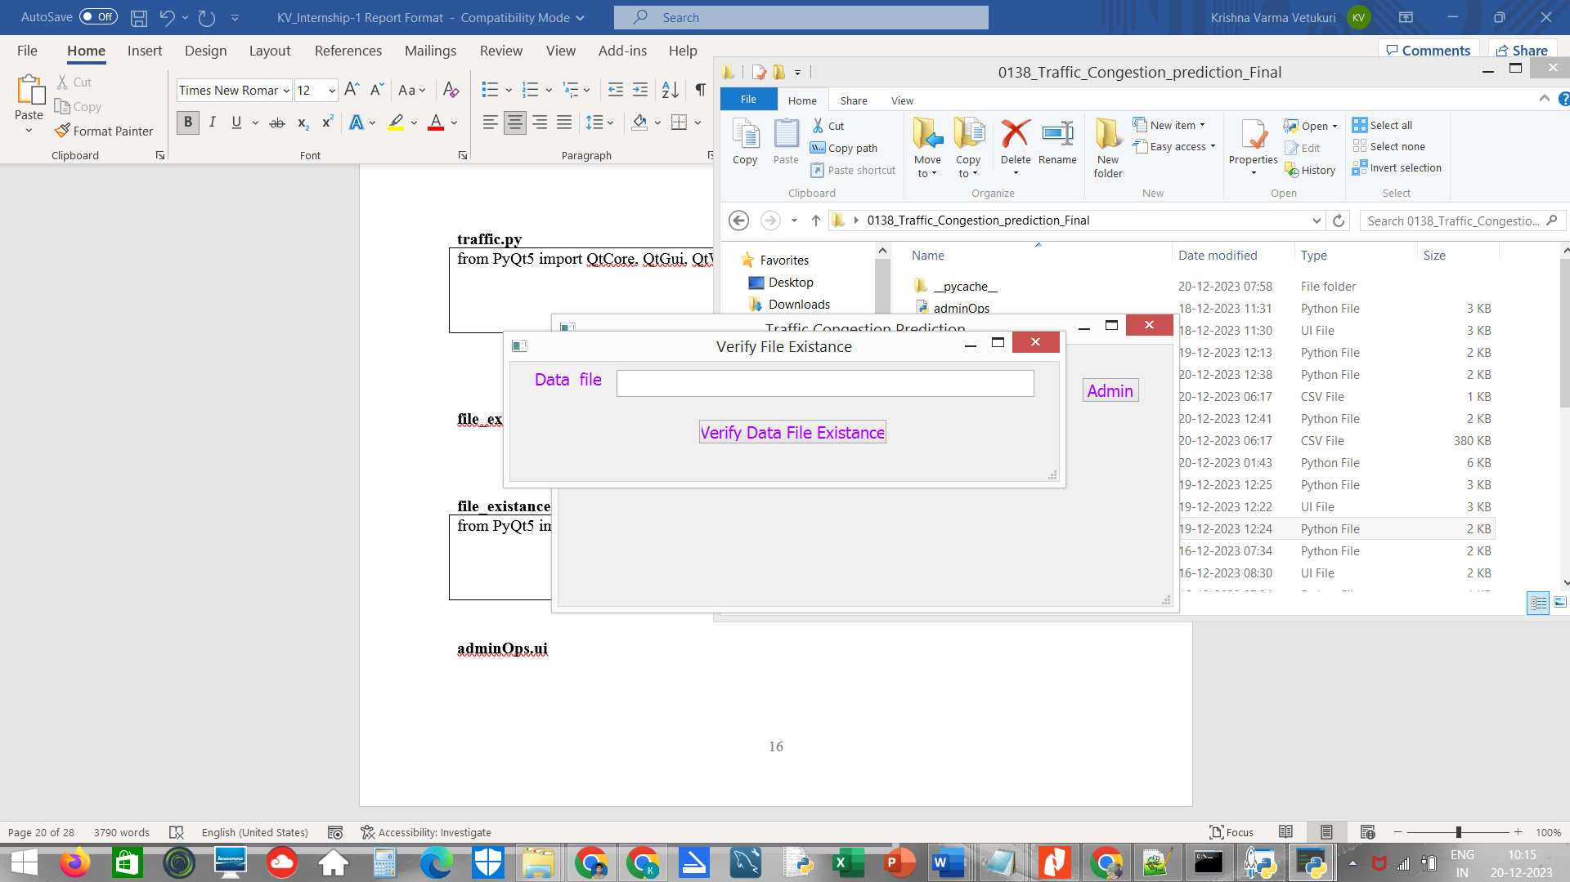

**Figure 11. file_existance.ui**

**file_existance.py**

|  |
| --- |
| from PyQt5 import QtCore, QtGui, QtWidgets  class Ui_MainWindow(object):  def setupUi(self, MainWindow):  MainWindow.setObjectName("MainWindow")  MainWindow.resize(671, 146)  MainWindow.setStyleSheet("color: rgb(170, 0, 255);\n"  "font: 75 12pt \"MS Shell Dlg 2\";")  self.centralwidget = QtWidgets.QWidget(MainWindow)  self.centralwidget.setObjectName("centralwidget")  self.pushButton = QtWidgets.QPushButton(self.centralwidget)  self.pushButton.setGeometry(QtCore.QRect(230, 70, 231, 31))  self.pushButton.setObjectName("pushButton")  self.lineEdit = QtWidgets.QLineEdit(self.centralwidget)  self.lineEdit.setGeometry(QtCore.QRect(130, 10, 511, 33))  self.lineEdit.setObjectName("lineEdit")  self.label = QtWidgets.QLabel(self.centralwidget)  self.label.setGeometry(QtCore.QRect(30, 10, 81, 21))  self.label.setObjectName("label")  MainWindow.setCentralWidget(self.centralwidget)  self.statusbar = QtWidgets.QStatusBar(MainWindow)  self.statusbar.setObjectName("statusbar")  MainWindow.setStatusBar(self.statusbar)  self.retranslateUi(MainWindow)  QtCore.QMetaObject.connectSlotsByName(MainWindow)  def retranslateUi(self, MainWindow):  _translate = QtCore.QCoreApplication.translate  MainWindow.setWindowTitle(_translate("MainWindow", "Verify File Existance"))  self.pushButton.setText(_translate("MainWindow", "Verify Data File Existance"))  self.label.setText(_translate("MainWindow", "Data file:")) |

**adminOps.ui**

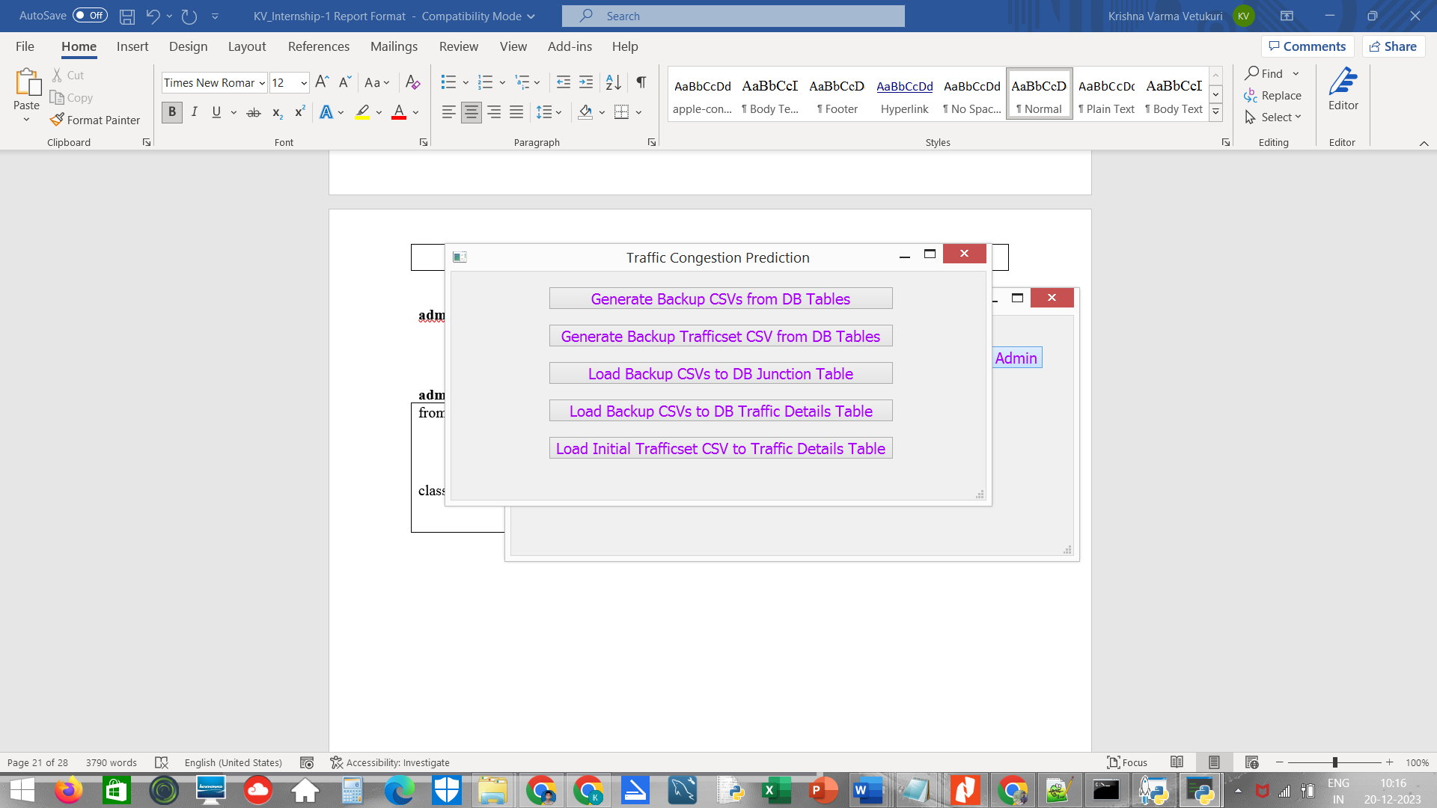

Figure 12. adminOps.ui

**adminOps.py**

|  |
| --- |
| from PyQt5 import QtCore, QtGui, QtWidgets  class Ui_MainWindow(object):  def setupUi(self, MainWindow):  MainWindow.setObjectName("MainWindow")  MainWindow.resize(714, 305)  MainWindow.setStyleSheet("color: rgb(170, 0, 255);\n"  "font: 75 12pt \"MS Shell Dlg 2\";")  self.centralwidget = QtWidgets.QWidget(MainWindow)  self.centralwidget.setObjectName("centralwidget")  self.pushButton = QtWidgets.QPushButton(self.centralwidget)  self.pushButton.setGeometry(QtCore.QRect(130, 120, 461, 31))  self.pushButton.setObjectName("pushButton")  self.pushButton_2 = QtWidgets.QPushButton(self.centralwidget)  self.pushButton_2.setGeometry(QtCore.QRect(130, 170, 461, 31))  self.pushButton_2.setObjectName("pushButton_2")  self.pushButton_4 = QtWidgets.QPushButton(self.centralwidget)  self.pushButton_4.setGeometry(QtCore.QRect(130, 220, 461, 31))  self.pushButton_4.setObjectName("pushButton_4")  self.pushButton_5 = QtWidgets.QPushButton(self.centralwidget)  self.pushButton_5.setGeometry(QtCore.QRect(130, 20, 461, 31))  self.pushButton_5.setObjectName("pushButton_5")  self.pushButton_6 = QtWidgets.QPushButton(self.centralwidget)  self.pushButton_6.setGeometry(QtCore.QRect(130, 70, 461, 31))  self.pushButton_6.setObjectName("pushButton_6")  MainWindow.setCentralWidget(self.centralwidget)  self.statusbar = QtWidgets.QStatusBar(MainWindow)  self.statusbar.setObjectName("statusbar")  MainWindow.setStatusBar(self.statusbar)  self.retranslateUi(MainWindow)  QtCore.QMetaObject.connectSlotsByName(MainWindow)  def retranslateUi(self, MainWindow):  _translate = QtCore.QCoreApplication.translate  MainWindow.setWindowTitle(_translate("MainWindow", "Traffic Congestion Prediction"))  self.pushButton.setText(_translate("MainWindow", "Load Backup CSVs to DB Junction Table"))  self.pushButton_2.setText(_translate("MainWindow", "Load Backup CSVs to DB Traffic Details Table"))  self.pushButton_4.setText(_translate("MainWindow", "Load Initial Trafficset CSV to Traffic Details Table"))  self.pushButton_5.setText(_translate("MainWindow", "Generate Backup CSVs from DB Tables"))  self.pushButton_6.setText(_translate("MainWindow", "Generate Backup Trafficset CSV from DB Tables"))  if __name__ == "__main__":  import sys  app = QtWidgets.QApplication(sys.argv)  MainWindow = QtWidgets.QMainWindow()  ui = Ui_MainWindow()  ui.setupUi(MainWindow)  MainWindow.show()  sys.exit(app.exec_()) |

**CHAPTER 5: CODING and TESTING**

As shown above the view of congest.ui there are 5 buttons which has its own function. The five buttons present on the home GUI screen are:

1. Junction Details

2. Traffic Details

3. Data File Existence Verification

4. Bi-Directional LSTM Analysis

5. Admin

The Home GUI screen is shown by using congest1.py where it will help in showing the congest.ui design to start the project. When we start executing the congest1.py then we get the following output

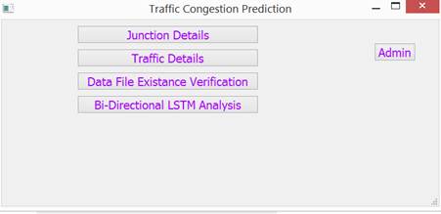

Figure 13. congest1.py

**congest1.py**

|  |
| --- |
| import sys  import os  from congest import *  from PyQt5 import QtWidgets, QtGui, QtCore  class MyForm(QtWidgets.QMainWindow):  def __init__(self,parent=None):  QtWidgets.QWidget.__init__(self,parent)  self.ui = Ui_MainWindow()  self.ui.setupUi(self)  self.ui.pushButton.clicked.connect(self.trdtls)  self.ui.pushButton_2.clicked.connect(self.dfexists)  self.ui.pushButton_4.clicked.connect(self.blstm)  self.ui.pushButton_5.clicked.connect(self.jndtls)  self.ui.pushButton_6.clicked.connect(self.admin_ops)  def trdtls(self):  os.system("python traffic1.py")  def dfexists(self):  os.system("python file_existance1.py")  def blstm(self):  os.system("python -W ignore bidirect_lstm1.py")  def jndtls(self):  os.system("python junction1.py")  def admin_ops(self):  os.system("python adminOps1.py")  if __name__ == "__main__":  app = QtWidgets.QApplication(sys.argv)  myapp = MyForm()  myapp.show()  sys.exit(app.exec_()) |

* 1. **Junction Details**

When the "Junction Details" button is clicked, the Junction1.py file is executed, displaying the design of the junction.ui interface. This interface allows users to input values for various junction details. Subsequently, clicking the "Store Junction Details in Database" button triggers the execution of the associated function.

The Junction1.py script, leveraging PyQt5 and SQLite3, establishes a connection to the 'traffic1' database. Upon clicking the "Store Junction Details in Database" button, the entered values, including junction name, city name, number of junctions, distance of the nearest junction, number of signals, number of incoming roads, and number of outgoing roads, are inserted into the 'jndtls' table in the database.

**junction1.py**

|  |
| --- |
| import sys  import os  from junction import *  from PyQt5 import QtWidgets, QtGui, QtCore  import sqlite3  con = sqlite3.connect('traffic1')  class MyForm(QtWidgets.QMainWindow):  def __init__(self,parent=None):  QtWidgets.QWidget.__init__(self,parent)  self.ui = Ui_MainWindow()  self.ui.setupUi(self)  self.ui.pushButton.clicked.connect(self.insertvalues)  def insertvalues(self):  with con:  cur = con.cursor()  jname = str(self.ui.lineEdit_9.text())  cname = str(self.ui.lineEdit_4.text())  njunc = str(self.ui.lineEdit_5.text())  distnj = str(self.ui.lineEdit_6.text())  sgnlsno = str(self.ui.lineEdit_7.text())  inroadsno = str(self.ui.lineEdit_8.text())  outroadsno = str(self.ui.lineEdit_10.text())  cur.execute('INSERT INTO jndtls(jname,cname,njunc,distnj,sgnlsno,inroadsno,outroadsno) VALUES(?,?,?,?,?,?,?)',(jname,cname,njunc,distnj,sgnlsno,inroadsno,outroadsno))  con.commit()  if __name__ == "__main__":  app = QtWidgets.QApplication(sys.argv)  myapp = MyForm()  myapp.show()  sys.exit(app.exec_()) |

**Output:**

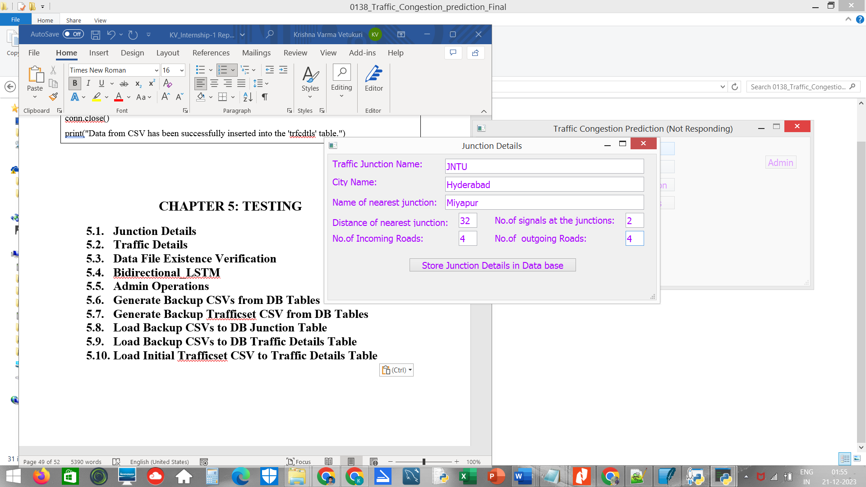

Figure 14. Junction Details Filling

On click on the button **“Store Junction Details in Data base”** the values of the Junction Details is stored in the database in 'jndtls' table

Values stored in the database in jndtlsTable

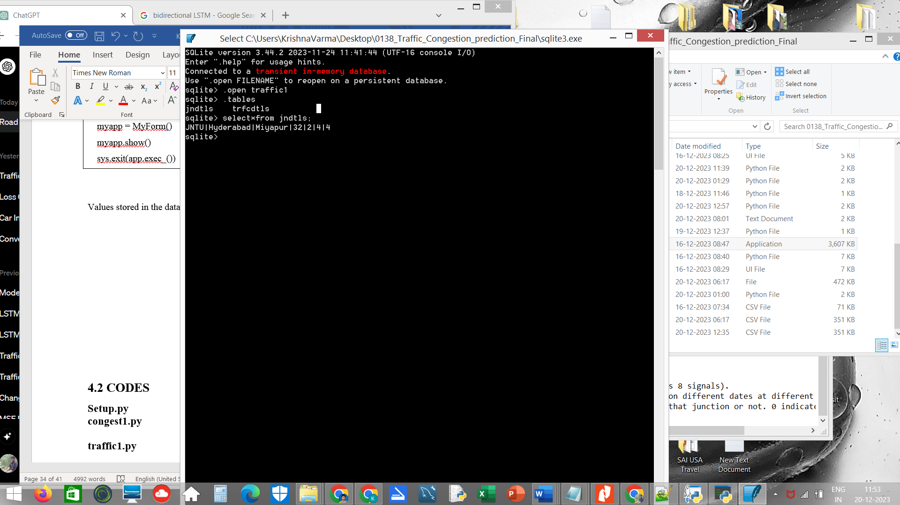

Figure 15. jndtls DB Table

* 1. **Traffic Details**

When the "Traffic Details" button is activated, the traffic1.py file is executed, unveiling the design of the traffic.ui interface. This interface facilitates the input of values for various traffic-related details. Upon clicking the "Store Traffic Details in Database" button, the associated function is triggered.

The traffic1.py script, utilizing PyQt5 and SQLite3, establishes a connection to the 'traffic1' database. Upon clicking the "Store Traffic Details in Database" button, the entered values, including junction name, traffic details for North, South, East, and West directions (both incoming and outgoing), are inserted into the 'trfcdtls' table in the database.

**traffic1.py**

|  |
| --- |
| import sys  import os  from traffic import *  from PyQt5 import QtWidgets, QtGui, QtCore  import sqlite3  con = sqlite3.connect('traffic1')  class MyForm(QtWidgets.QMainWindow):  def __init__(self,parent=None):  QtWidgets.QWidget.__init__(self,parent)  self.ui = Ui_MainWindow()  self.ui.setupUi(self)  self.ui.pushButton.clicked.connect(self.insertvalues)  def insertvalues(self):  with con:  cur = con.cursor()  jname = str(self.ui.lineEdit_9.text())  RD_tfc_N1i = str(self.ui.lineEdit_3.text())  RD_tfc_N1o = str(self.ui.lineEdit_4.text())  RD_tfc_N2i = str(self.ui.lineEdit_5.text())  RD_tfc_N2o = str(self.ui.lineEdit_6.text())  RD_tfc_S1i = str(self.ui.lineEdit_2.text())  RD_tfc_S1o = str(self.ui.lineEdit_10.text())  RD_tfc_E1i = str(self.ui.lineEdit_7.text())  RD_tfc_E1o = str(self.ui.lineEdit_8.text())  RD_tfc_W1i = str(self.ui.lineEdit_12.text())  RD_tfc_W1o = str(self.ui.lineEdit_11.text())  cur.execute('INSERT INTO trfcdtls(jname,RD_tfc_N1i,RD_tfc_N1o,RD_tfc_N2i,RD_tfc_N2o,RD_tfc_S1i,RD_tfc_S1o,RD_tfc_E1i,RD_tfc_E1o,RD_tfc_W1i,RD_tfc_W1o) VALUES(?,?,?,?,?,?,?,?,?,?,?)',(jname,RD_tfc_N1i,RD_tfc_N1o,RD_tfc_N2i,RD_tfc_N2o,RD_tfc_S1i,RD_tfc_S1o,RD_tfc_E1i,RD_tfc_E1o,RD_tfc_W1i,RD_tfc_W1o))  con.commit()  if __name__ == "__main__":  app = QtWidgets.QApplication(sys.argv)  myapp = MyForm()  myapp.show()  sys.exit(app.exec_()) |

Output:

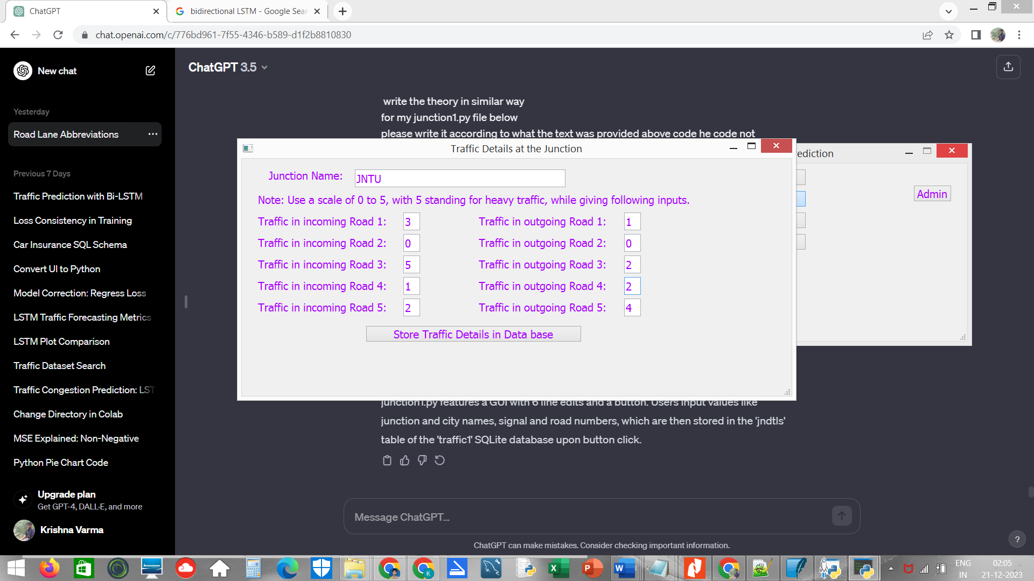

Figure 16. Traffic Details Filling

On click on the button **“Store Traffic Details in Data base”** the values of the Traffic Details is stored in the database in 'trfcdtls' table

Values stored in the database in trfcdtlsTable

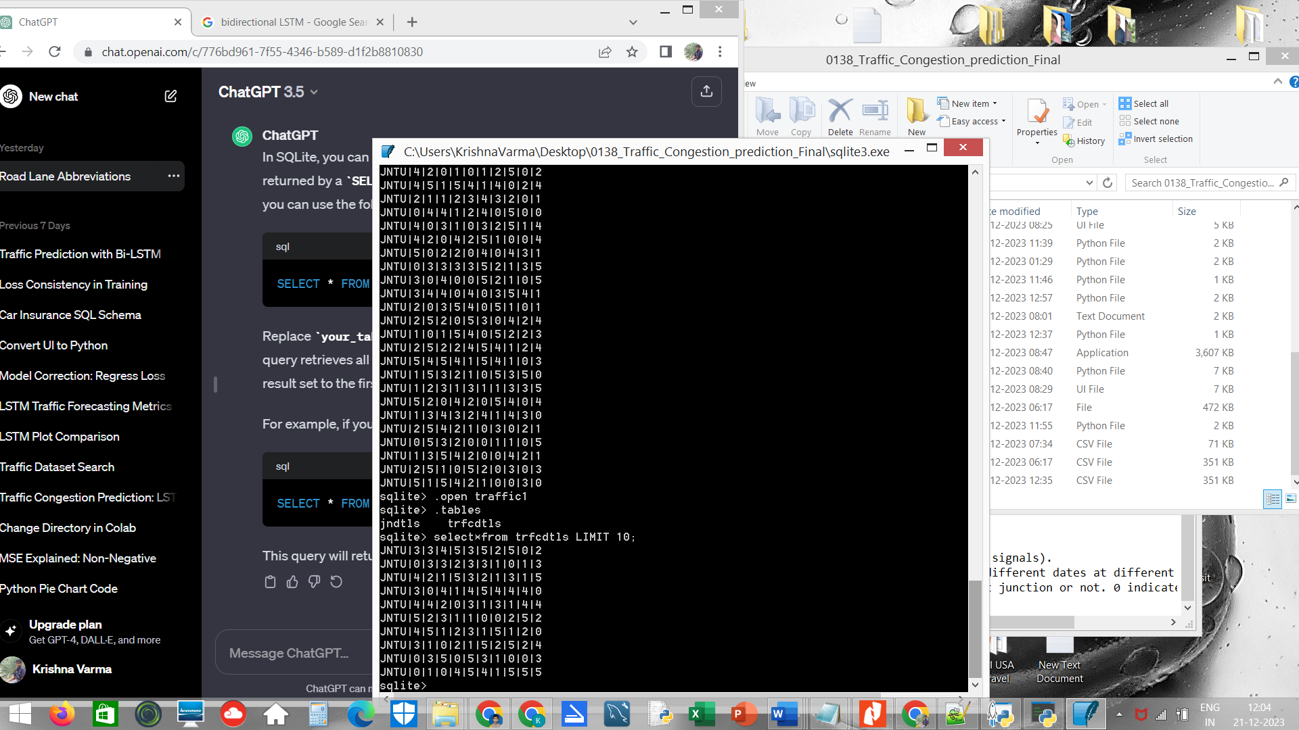

Figure 17. trfcdtls DB Table

* 1. **Data File Existence Verification**

When we execute the file_existance.py script, it initiates a graphical user interface (GUI) using PyQt5, designed in the file_existance.ui file. The GUI contains a text input field and a button. The purpose of this GUI is to check the existence of a file based on the user's input.

**file_existance1.py**

|  |
| --- |
| import sys  import os  from file_existance import *  from PyQt5 import QtWidgets, QtGui, QtCore  class MyForm(QtWidgets.QMainWindow):  def __init__(self,parent=None):  QtWidgets.QWidget.__init__(self,parent)  self.ui = Ui_MainWindow()  self.ui.setupUi(self)  self.ui.pushButton.clicked.connect(self.checkfile1)  def checkfile1(self):  fname = str(self.ui.lineEdit.text())  if (os.path.isfile(fname)):  print(' file exists')  else:  print(' file does not exists')  if __name__ == "__main__":  app = QtWidgets.QApplication(sys.argv)  myapp = MyForm()  myapp.show()  sys.exit(app.exec_()) |

**Output:**

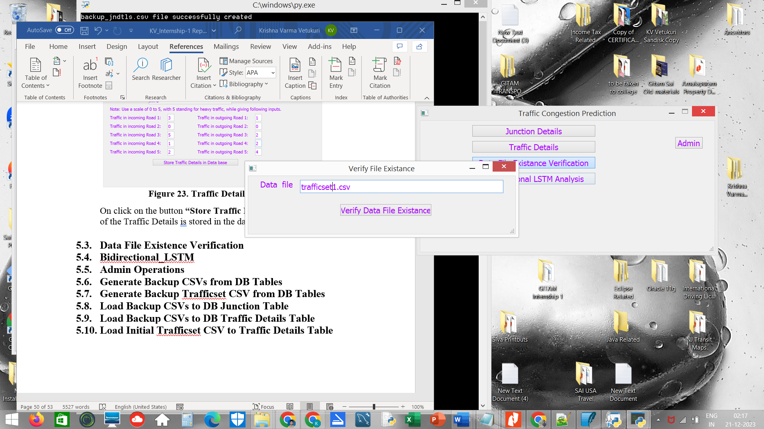

Figure 18. file_existance1.py

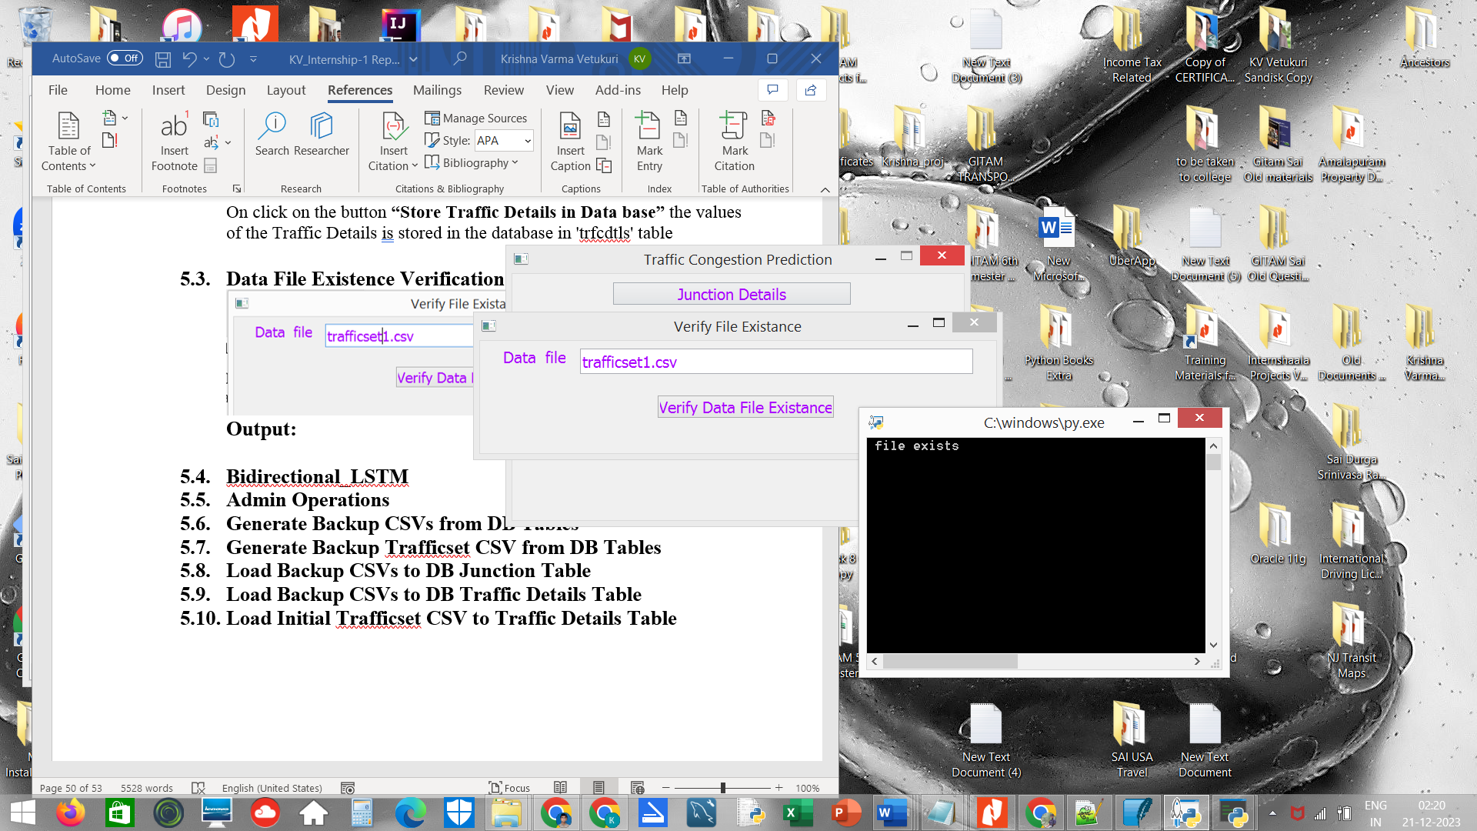

**Figure 19. file_existance1.py output**

* 1. **Bi-directional LSTM**

In this code, a time series dataset related to traffic is loaded and preprocessed. A Bidirectional LSTM (Long Short-Term Memory) model is implemented using TensorFlow and trained on the data. The model's performance is evaluated, and predictions are made for the next 90 time intervals. The original data, predicted values, and a combination of both are visualized using matplotlib, providing insights into the LSTM model's predictive capabilities for traffic-related time series data.

**bidirect_lstm1.py**

|  |
| --- |
| import pandas as pd  df=pd.read_csv('trafficset1.csv')  #RD_tfc_Total Column is Taken into dataframe df1 and reset the RD_tfc_Total column as index.  df1=df.reset_index()['RD_tfc_Total']  import matplotlib.pyplot as plt  import numpy as np  from sklearn.preprocessing import MinMaxScaler  scaler=MinMaxScaler(feature_range=(0,1))  df1=scaler.fit_transform(np.array(df1).reshape(-1,1))  training_size=int(len(df1)*0.75) #splitting dataset into train and test split  test_size=len(df1)-training_size  train_data,test_data=df1[0:training_size,:],df1[training_size:len(df1),:1]  print('sizes of Training and Testing sets are:',training_size,test_size)  # convert an array of values into a dataset matrix  def create_dataset(dataset, time_step=1):  dataX, dataY = [], []  for i in range(len(dataset)-time_step-1):  a = dataset[i:(i+time_step), 0]  dataX.append(a)  dataY.append(dataset[i + time_step, 0])  return np.array(dataX), np.array(dataY)  time_step = 100  X_train, y_train = create_dataset(train_data, time_step)  X_test, ytest = create_dataset(test_data, time_step)  # reshape input to be [samples, time steps, features] which is required for LSTM  X_train =X_train.reshape(X_train.shape[0],X_train.shape[1] , 1)  X_test = X_test.reshape(X_test.shape[0],X_test.shape[1] , 1)  #Create the Stacked LSTM model  from tensorflow.keras.models import Sequential  from tensorflow.keras.layers import Dense  from tensorflow.keras.layers import LSTM  from keras.layers import Bidirectional  model=Sequential()  model.add(Bidirectional(LSTM(50,return_sequences=True,input_shape=(100,1))))  model.add(Bidirectional(LSTM(50,return_sequences=True)))  model.add(Bidirectional(LSTM(50)))  model.add(Dense(1))  model.compile(loss='mean_squared_error',optimizer='adam')  history = model.fit(X_train,y_train,validation_data=(X_test,ytest),epochs=100,batch_size=64,verbose=1) #64  model.summary()  loss = history.history['loss']  val_loss = history.history['val_loss']  # Plotting loss and validation loss  plt.plot(loss, label='Training Loss')  plt.plot(val_loss, label='Validation Loss')  plt.title('Model Loss')  plt.xlabel('Epochs')  plt.ylabel('Loss')  plt.legend()  plt.show()  import tensorflow as tf  # prediction and check performance metrics  train_predict=model.predict(X_train)  test_predict=model.predict(X_test)  #Transformback to original form  train_predict=scaler.inverse_transform(train_predict)  test_predict=scaler.inverse_transform(test_predict)  # Calculate RMSE performance metrics  import math  from sklearn.metrics import mean_squared_error  print("Train Data RMSE:",math.sqrt(mean_squared_error(y_train,train_predict)))  print("Test Data RMSE:",math.sqrt(mean_squared_error(ytest,test_predict)))  # shift train predictions for plotting  look_back=100  trainPredictPlot = numpy.empty_like(df1)  trainPredictPlot[:, :] = np.nan  trainPredictPlot[look_back:len(train_predict)+look_back, :] = train_predict  # shift test predictions for plotting  testPredictPlot = numpy.empty_like(df1)  testPredictPlot[:, :] = numpy.nan  testPredictPlot[len(train_predict)+(look_back*2)+1:len(df1)-1, :] = test_predict  # plot baseline and predictions  plt.plot(scaler.inverse_transform(df1))  plt.plot(trainPredictPlot)  plt.plot(testPredictPlot)  plt.show()  print(len(test_data))  x_input=test_data[len(test_data)-100+1:].reshape(1,-1)  x_input.shape  temp_input=list(x_input)  temp_input=temp_input[0].tolist()  temp_input  # prediction for next 90 units of time intervals  from numpy import array  lst_output=[]  n_steps=100  i=0  while(i<90):  if(len(temp_input)>100):  x_input=np.array(temp_input[1:])  x_input=x_input.reshape(1,-1)  x_input = x_input.reshape((1, n_steps, 1))  yhat = model.predict(x_input, verbose=0)  temp_input.extend(yhat[0].tolist())  temp_input=temp_input[1:]  lst_output.extend(yhat.tolist())  i=i+1  else:  x_input = x_input.reshape((1, n_steps-1,1))  yhat = model.predict(x_input, verbose=0)  temp_input.extend(yhat[0].tolist())  lst_output.extend(yhat.tolist())  i=i+1  day_new=np.arange(1,101)  day_pred=np.arange(101,191)  plt.plot(day_new,scaler.inverse_transform(df1[len(df1)-100:]))  plt.title('LSTM Plot of Existing Data')  plt.show()  plt.plot(day_pred,scaler.inverse_transform(lst_output))  plt.title('LSTM Plot of Predicted Data')  plt.show()  plt.plot(day_new,scaler.inverse_transform(df1[len(df1)-100:]))  plt.plot(day_pred,scaler.inverse_transform(lst_output))  plt.title('LSTM Plot of Existing Data with Predicted')  plt.show()  df3 = df1[len(df1)-200:].tolist()  df3.extend(lst_output)  df3 = scaler.inverse_transform(df3).tolist()  plt.plot(df3)  plt.title('LSTM Prediction with Original Data')  plt.show() |

**Results:**

The Bi-Directional LSTM model is trained and tested on the 'trafficset1.csv' dataset, with the RD_tfc_Total column as the target variable. The training and testing sizes are split into 75% and 25%, respectively. The model is then evaluated based on its loss and validation loss, visualized through plots. Predictions are made for both training and testing sets, and their performance metrics, such as RMSE, are calculated. The final plots display the model's predictions compared to the original data. The outputs include visualizations of the existing data, predicted data, existing data with predictions, and the LSTM prediction merged with the original data.

**Output:**

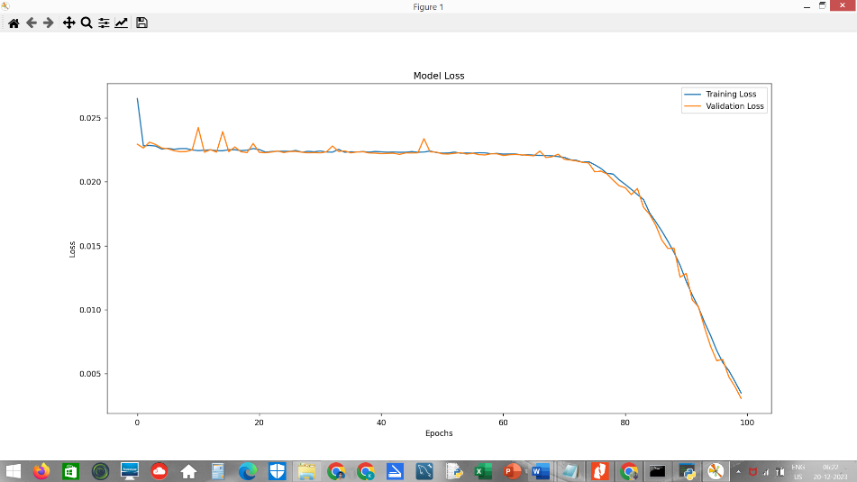

Figure 20. Plot Loss and RMSE loss vs Epochs

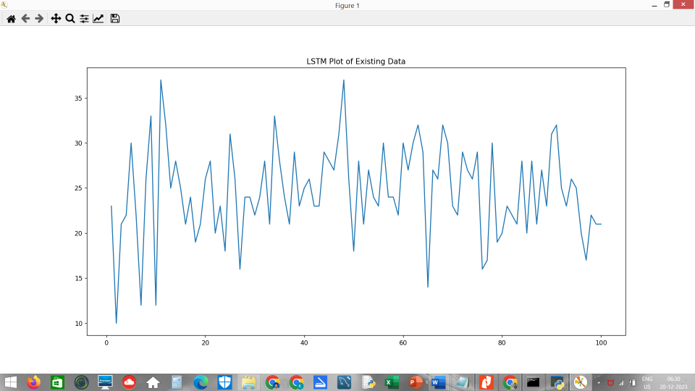

Figure 21. LSTM Plot of Existing Data

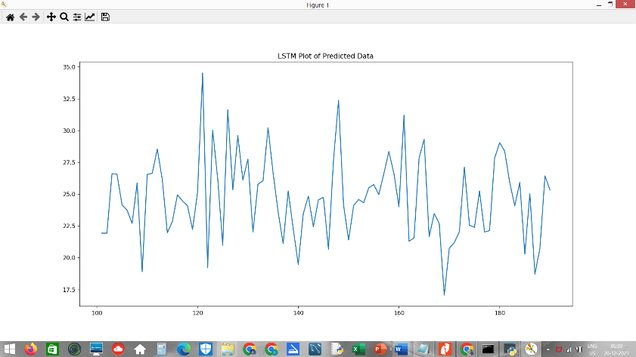

Figure 22. LSTM Plot of Predicted Data

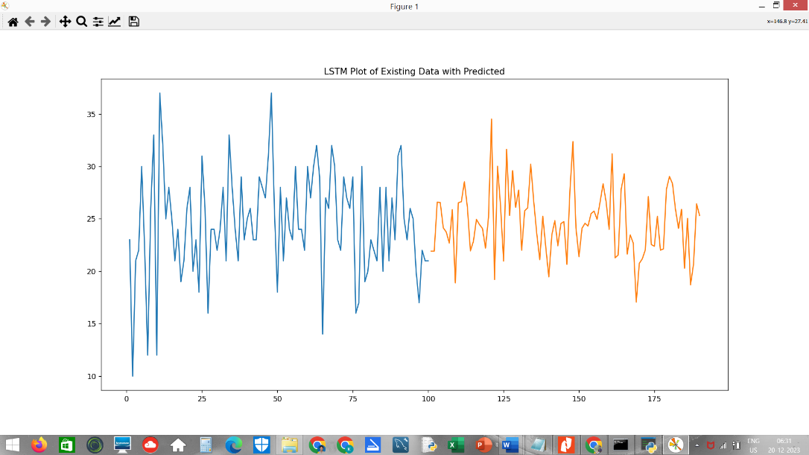

Figure 23. LSTM Plot of Existing with Predicted Data

* 1. **Admin Operations**

This is only for the admin who can easily add large csv data to the database and can also retrieve data to store as a backup.

**adminOps1.py**

|  |
| --- |
| import sys  import os  from adminOps import *  from PyQt5 import QtWidgets, QtGui, QtCore  class AdminOpsForm(QtWidgets.QMainWindow):  def __init__(self, parent=None):  QtWidgets.QWidget.__init__(self, parent)  self.ui = Ui_MainWindow()  self.ui.setupUi(self)  self.ui.pushButton.clicked.connect(self.backup_junction_table)  self.ui.pushButton_2.clicked.connect(self.backup_traffic_details_table)  self.ui.pushButton_4.clicked.connect(self.load_initial_traffic_to_db)  self.ui.pushButton_5.clicked.connect(self.generate_backup_csvs)  self.ui.pushButton_6.clicked.connect(self.generate_backup_trafficset_csv)  def backup_junction_table(self):  os.system("python load_jndtls_DBtable_csv_to_db.py")  def backup_traffic_details_table(self):  os.system("python load_trfcdtls_DBtable_csv_to_db.py")  def load_initial_traffic_to_db(self):  os.system("python load_intial_traffic_csv_to_db.py")  def generate_backup_csvs(self):  os.system("python backup_DB_tables_to_csv.py")  def generate_backup_trafficset_csv(self):  os.system("python backup_trafficset_to_csv.py")  if __name__ == "__main__":  app = QtWidgets.QApplication(sys.argv)  admin_app = AdminOpsForm()  admin_app.show()  sys.exit(app.exec_()) |

**Output:**

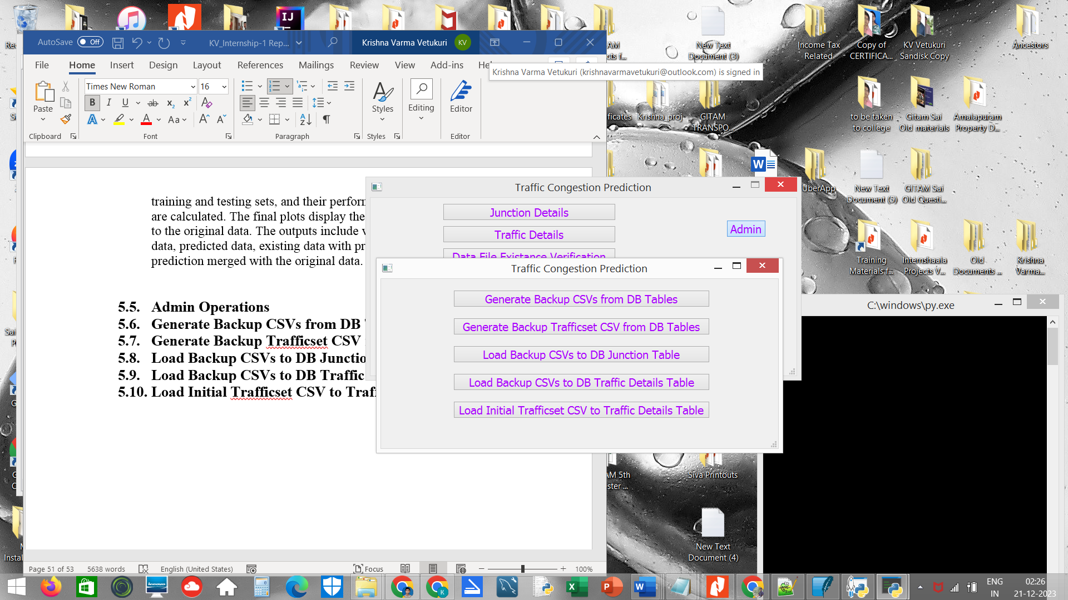

Figure 24. Admin Operation Buttons

* 1. **Generate Backup CSVs from DB Tables**

This ensures that the database data is securely stored in CSV format, serving as a valuable backup in case of any unexpected crashes or data loss in the database.

**backup_DB_tables_to_csv.py**

|  |
| --- |
| import sqlite3  import csv  con = sqlite3.connect('traffic1')  cur = con.cursor()  cur.execute('SELECT * FROM jndtls;') # For Junction Table  rows = cur.fetchall()  fp = open('backup_jndtls.csv', 'w', newline='') # Use 'newline='' for Windows compatibility  myFile = csv.writer(fp)  myFile.writerows([["jname", "cname", "njunc", "distnj", "sgnlsno", "inroadsno", "outroadsno"]])  myFile.writerows(rows)  fp.close()  print('backup_jndtls.csv file successfully created')  cur.execute('SELECT * FROM trfcdtls;') # For Traffic Details Table  rows = cur.fetchall()  fp = open('backup_trfcdtls.csv', 'w', newline='') # Use 'newline='' for Windows compatibility  myFile = csv.writer(fp)  myFile.writerows([["jname", "RD_tfc_N1i", "RD_tfc_N1o", "RD_tfc_N2i", "RD_tfc_N2o", "RD_tfc_S1i", "RD_tfc_S1o", "RD_tfc_E1i", "RD_tfc_E1o", "RD_tfc_W1i", "RD_tfc_W1o"]])  myFile.writerows(rows)  fp.close()  print('backup_trfcdtls.csv file successfully created')  con.commit()  con.close() |

**Output:**

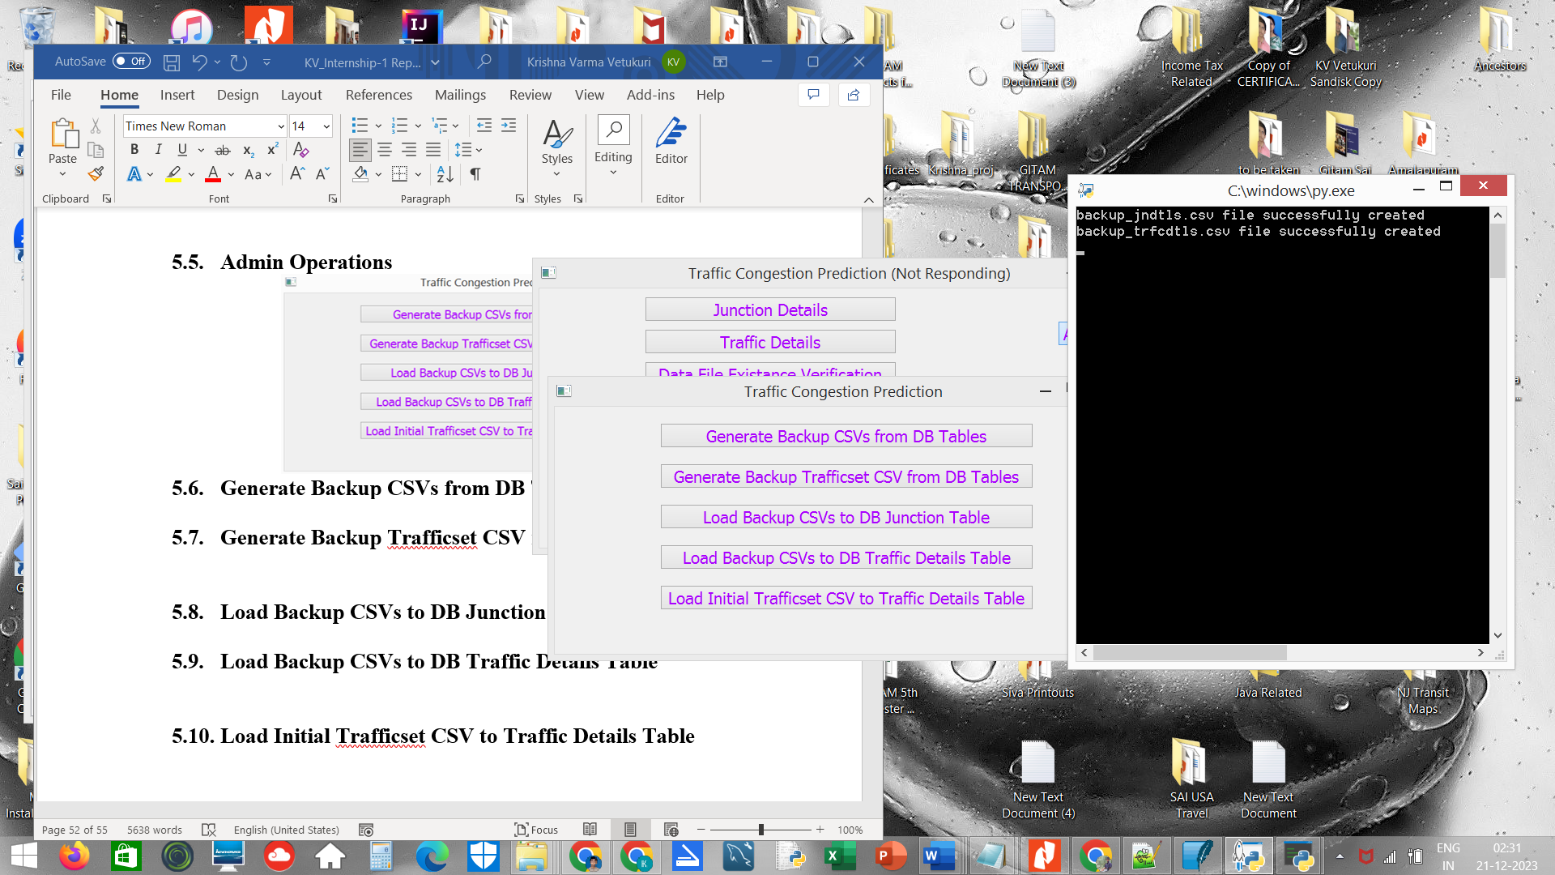

**Figure 25. General Backup CSVs from DB Table cmd**

The csv files are produced in the same directory that the project is running, we those will be used for further functions.

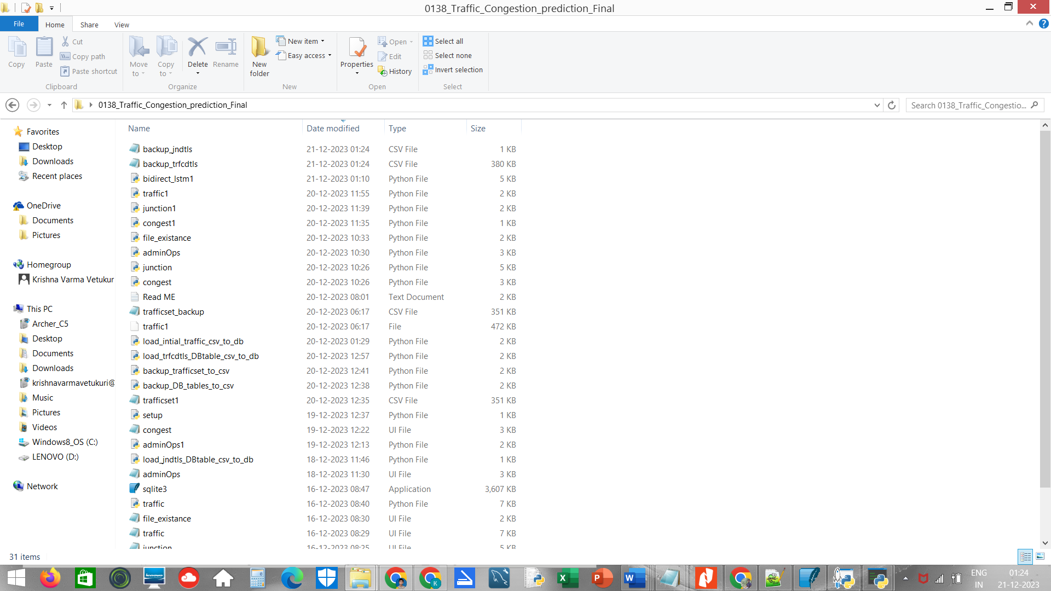

Figure 26. General Backup CSVs in file

* 1. **Generate Backup Trafficset CSV from DB Tables**

This backup serves as a critical resource for future model training, ensuring that the model stays up-to-date with the latest and most relevant traffic data even in the event of a database crash or data loss.

**backup_trafficset_to_csv.py**

|  |
| --- |
| import sqlite3  import csv  conn = sqlite3.connect('traffic1')  cursor = conn.cursor()  cursor.execute('SELECT * FROM trfcdtls;')  rows = cursor.fetchall()  modified_data = []  for row in rows:  traffic_data = list(map(int, row[1:11]))  total = sum(traffic_data)  modified_data.append(traffic_data + [total])  conn.close()  with open('trafficset_backup.csv', 'w', newline='') as csvfile:  csvwriter = csv.writer(csvfile)  csvwriter.writerow([ "RD_tfc_N1i", "RD_tfc_N1o", "RD_tfc_N2i", "RD_tfc_N2o", "RD_tfc_S1i", "RD_tfc_S1o", "RD_tfc_E1i", "RD_tfc_E1o", "RD_tfc_W1i", "RD_tfc_W1o", "RD_tfc_Total"])  csvwriter.writerows(modified_data)  print('trafficset_backup.csv file successfully created.') |

**Output:**

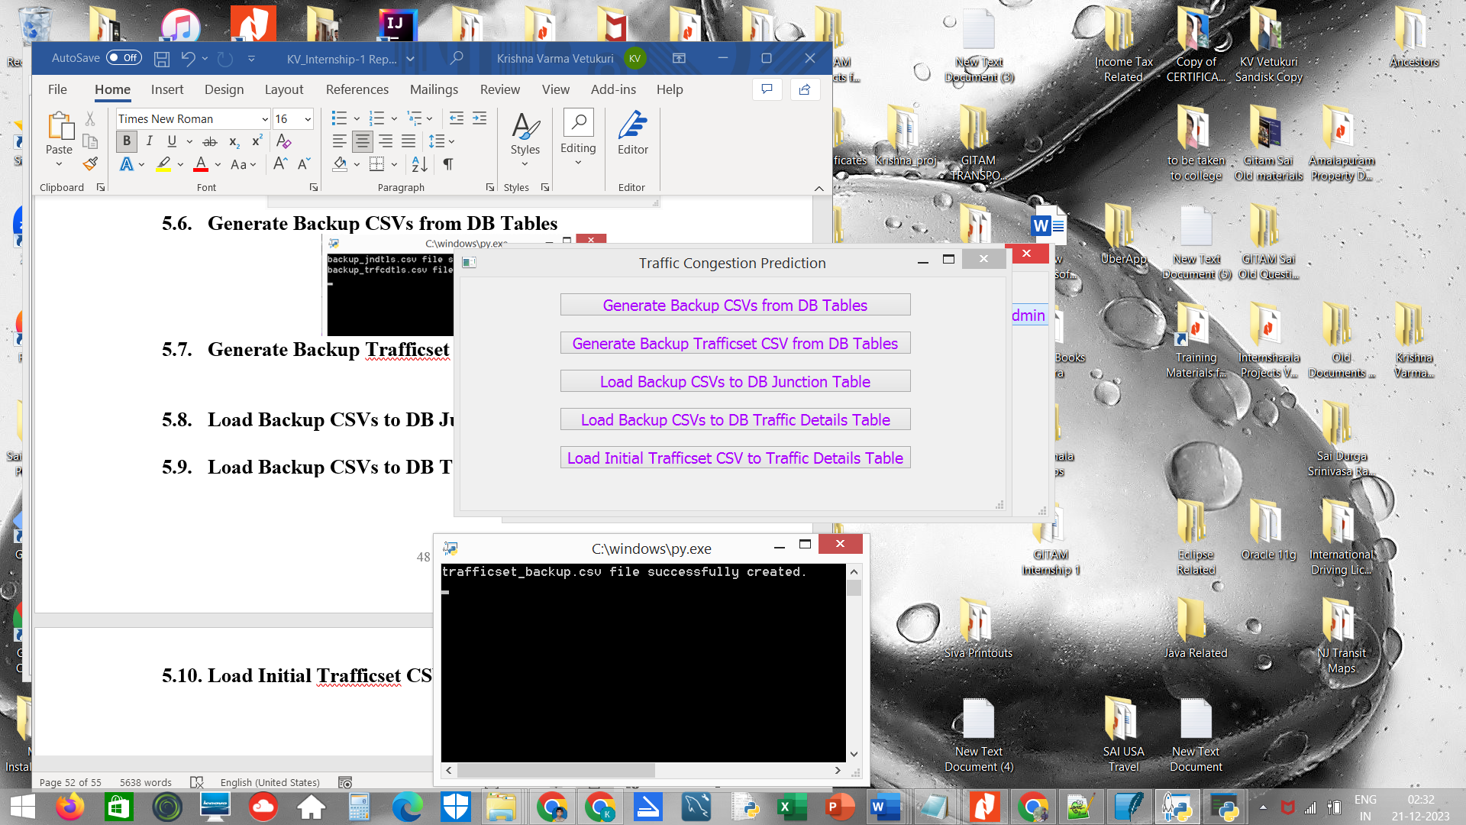

**Figure 27. Generate Backup Trafficset CSV**

The csv files are produced in the same directory that the project is running, we those will be used for further functions.

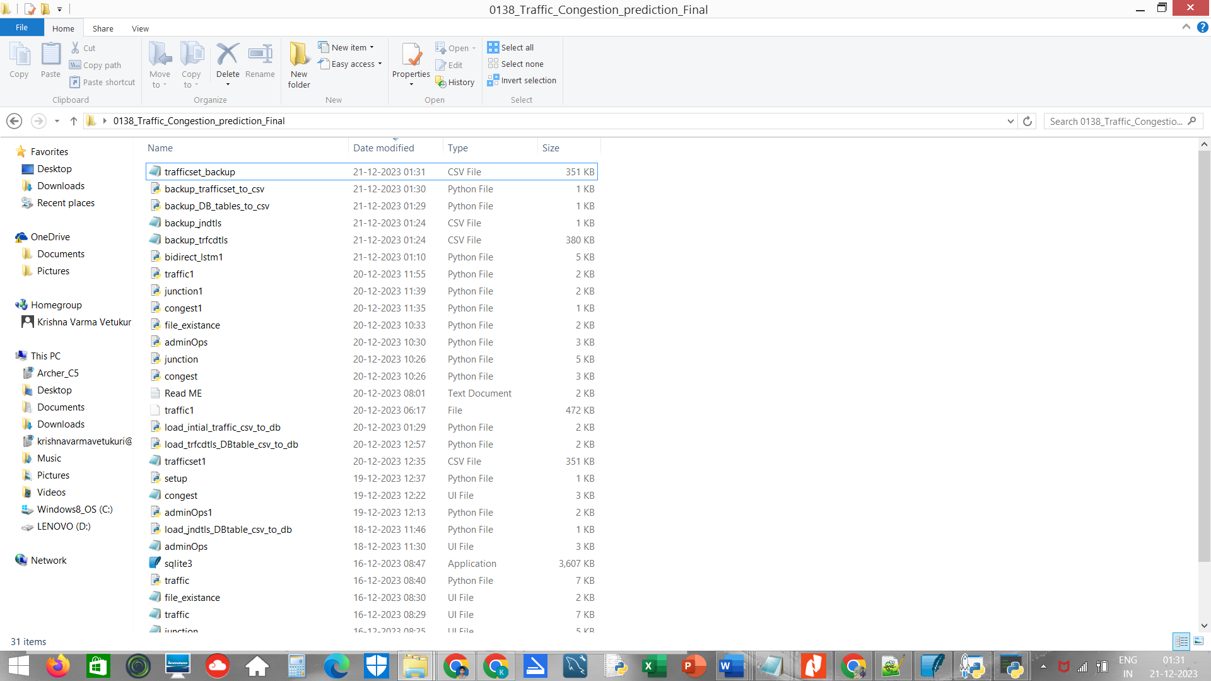

**Figure 28. Generate Backup Trafficset CSV in file**

* 1. **Load Backup CSVs to DB Junction Table**

This ensures that the stored backup data can be easily retrieved and utilized to restore or update the Junction Table, maintaining the integrity of the database even after potential disruptions or data loss.

**load_jndtls_DBtable_csv_to_db.py**

|  |
| --- |
| import sqlite3  import csv  con = sqlite3.connect('traffic1')  cur = con.cursor()  cur.execute('''  CREATE TABLE IF NOT EXISTS jndtls (  jname varchar(40),  jname varchar(40),  njunc varchar(40),  distnj char(2),  sgnlsno char(2),  inroadsno char(2),  outroadsno char(2)  ) ''')  cur.execute('DELETE FROM jndtls;')  with open('backup_jndtls.csv', 'r') as csvfile:  csvreader = csv.reader(csvfile)  next(csvreader)  for row in csvreader:  cur.execute('INSERT INTO jndtls VALUES (?, ?, ?, ?, ?, ?, ?)', row)  con.commit()  con.close()  print('Data inserted into jndtls table successfully.') |

**Output:**

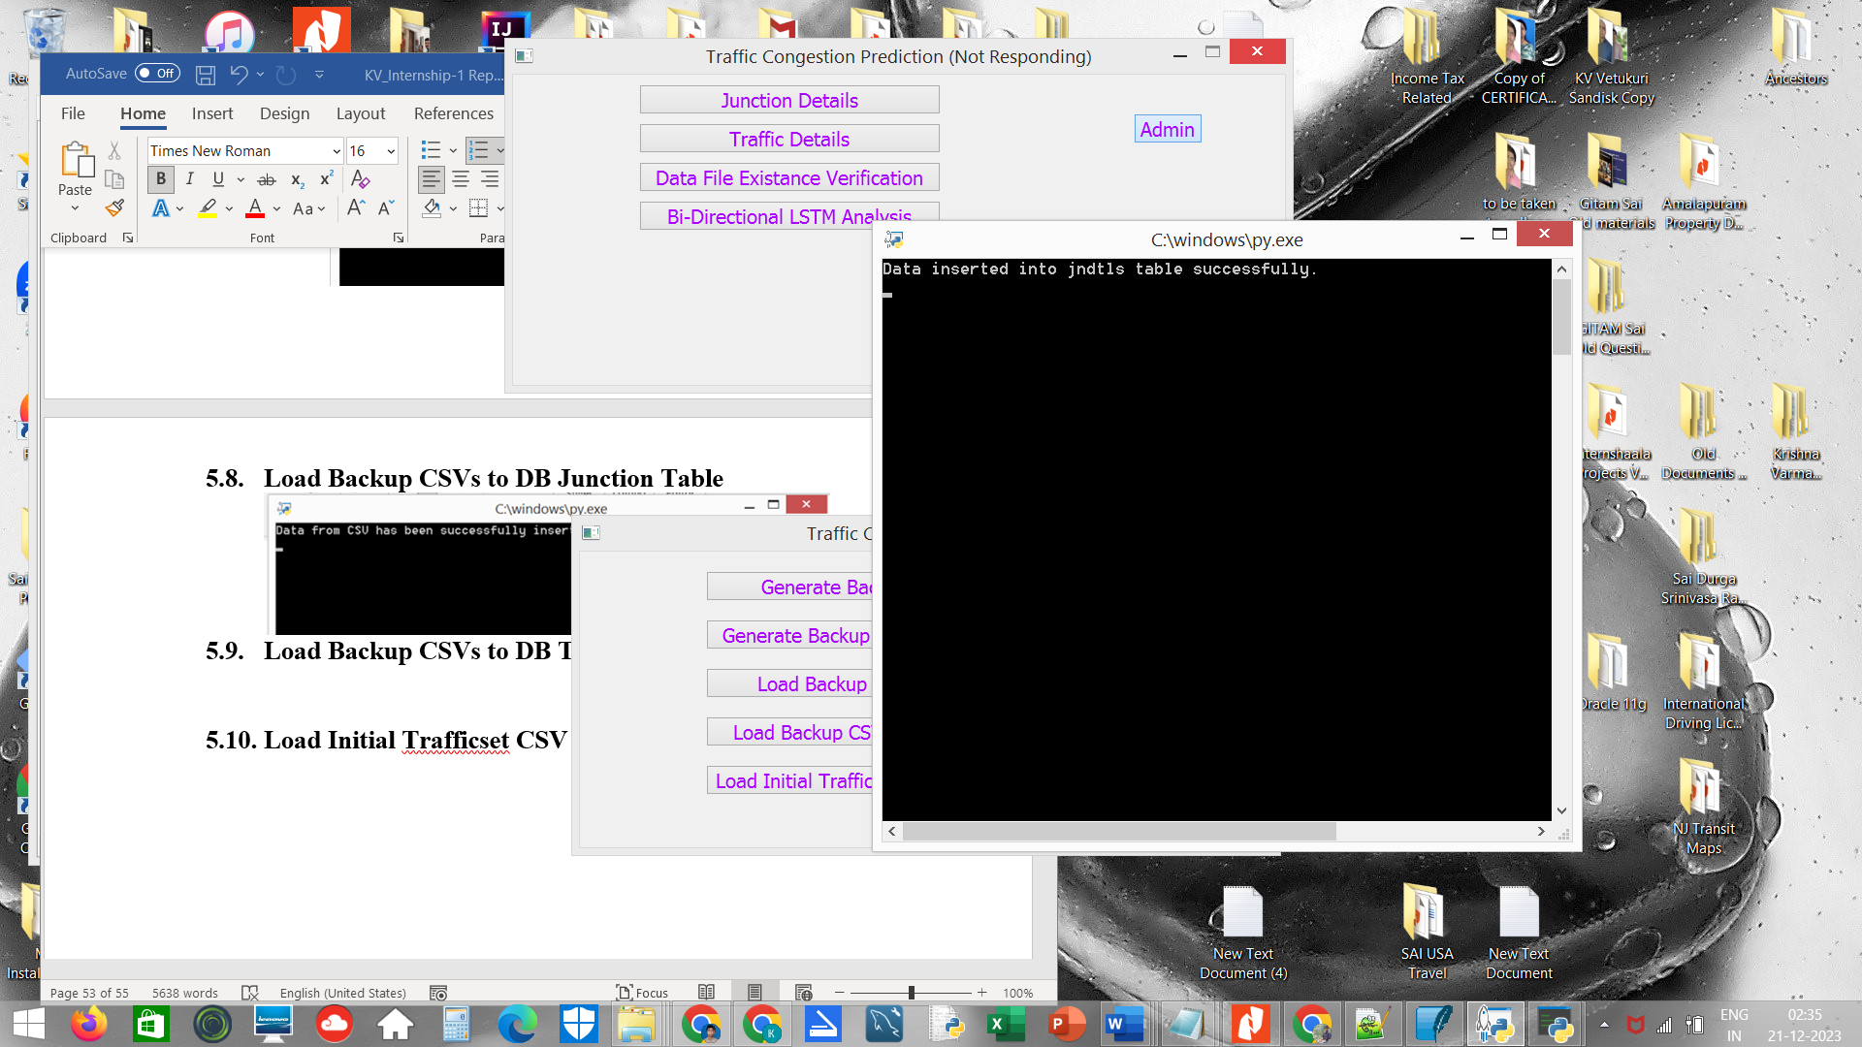

**Figure 29. Load Backup CSVs to DB Junction Table**

* 1. **Load Backup CSVs to DB Traffic Details Table**

This ensures that the backup data can be efficiently reintegrated into the system, contributing to the reliability and completeness of the Traffic Details Table in case of any database-related issues or data loss.

**load_trfcdtls_DBtable_csv_to_db.py**

|  |
| --- |
| import sqlite3  import csv  con = sqlite3.connect('traffic1')  cur = con.cursor()  cur.execute(''' CREATE TABLE IF NOT EXISTS trfcdtls (  jname varchar(40),  RD_tfc_N1i char(1),  RD_tfc_N1o char(1),  RD_tfc_N2i char(1),  RD_tfc_N2o char(1),  RD_tfc_S1i char(1),  RD_tfc_S1o char(1),  RD_tfc_E1i char(1),  RD_tfc_E1o char(1),  RD_tfc_W1i char(1),  RD_tfc_W1o char(1)  ); ''')  cur.execute('DELETE FROM trfcdtls;')  with open('backup_trfcdtls.csv', 'r') as csvfile:  csvreader = csv.reader(csvfile)  next(csvreader)  for row in csvreader:  cur.execute('INSERT INTO trfcdtls VALUES (?, ?, ?, ?, ?, ?, ?, ?, ?, ?, ?)', row)  con.commit()  con.close()  print('Data inserted into trfcdtls table successfully.') |

**Output:**

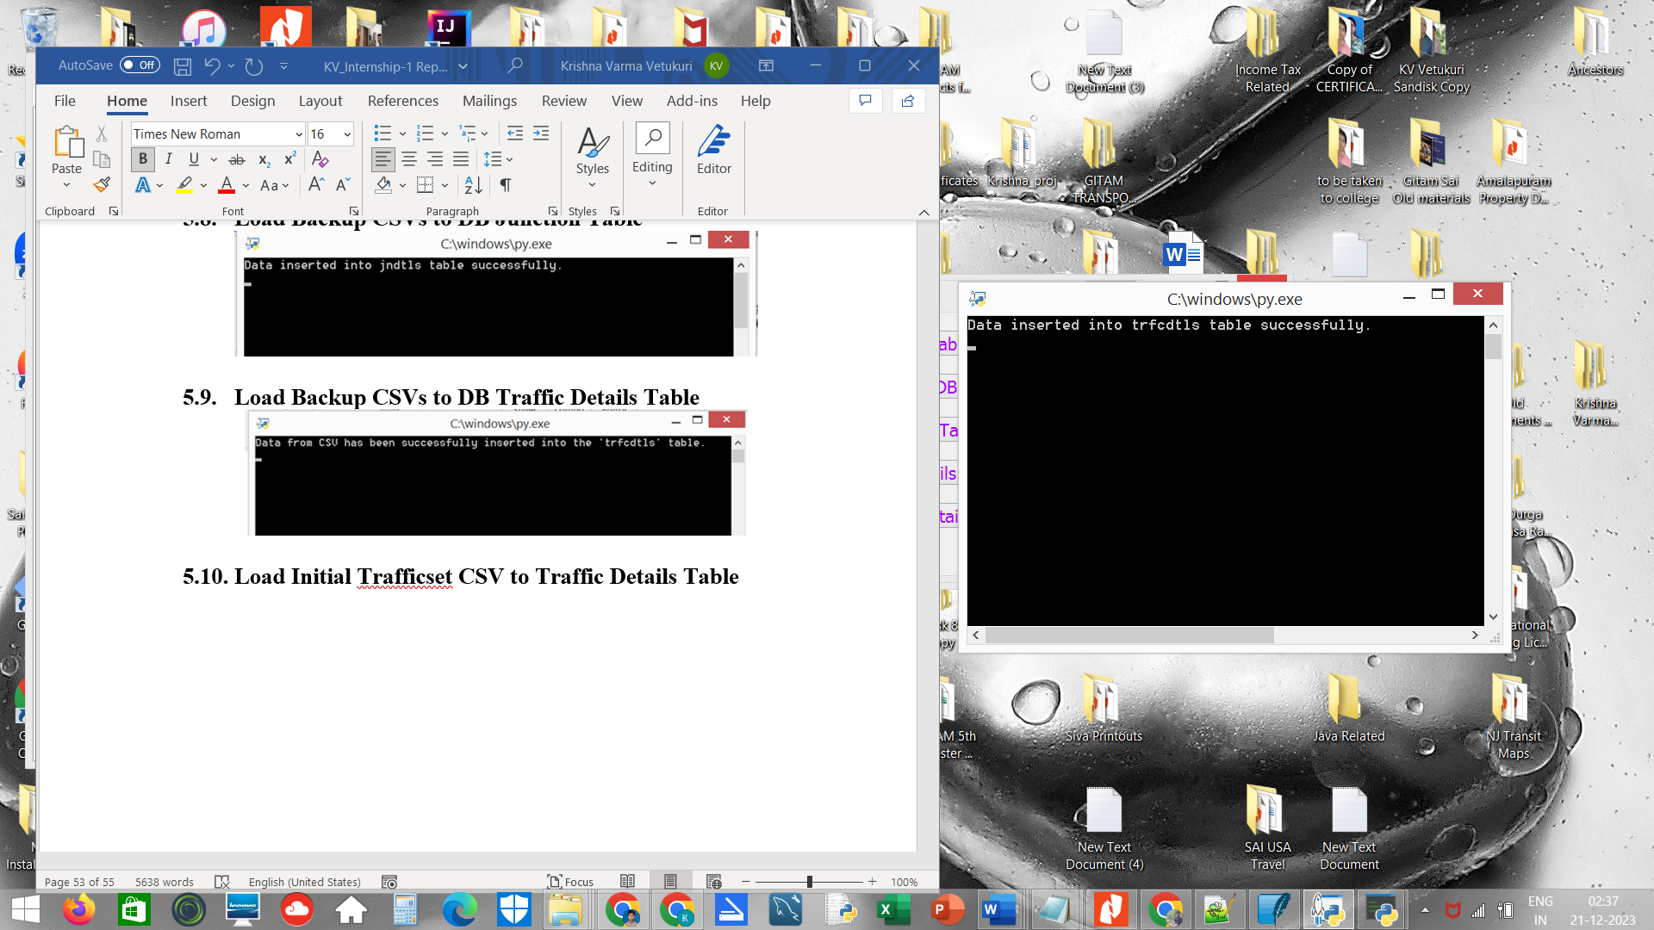

**Figure 30. Load Backup CSVs to DB Traffic Table**

* 1. **Load Initial Trafficset CSV to Traffic Details Table**

This process ensures that the project starts with relevant and foundational traffic data, setting the stage for accurate predictions and analyses based on the historical information captured in the "Trafficset" CSV file.

**load_intial_traffic_csv_to_db.py**

|  |
| --- |
| import sqlite3  import csv  conn = sqlite3.connect('traffic1')  cur = conn.cursor()  cur.execute('''  CREATE TABLE IF NOT EXISTS trfcdtls (  jname varchar(40),  RD_tfc_N1i char(1),  RD_tfc_N1o char(1),  RD_tfc_N2i char(1),  RD_tfc_N2o char(1),  RD_tfc_S1i char(1),  RD_tfc_S1o char(1),  RD_tfc_E1i char(1),  RD_tfc_E1o char(1),  RD_tfc_W1i char(1),  RD_tfc_W1o char(1)  );  ''')  cur.execute('DELETE FROM trfcdtls;')  with open('trafficset1.csv', 'r') as csvfile:  csvreader = csv.reader(csvfile)  next(csvreader)  for row in csvreader:  jname = 'JNTU'  RD_tfc_N1i,RD_tfc_N1o,RD_tfc_N2i,RD_tfc_N2o,RD_tfc_S1i,RD_tfc_S1o,RD_tfc_E1i,RD_tfc_E1o,RD_tfc_W1i,RD_tfc_W1o,RD_tfc_Total = map(int, row) # Skip the last column 'Total'  cur.execute('''  INSERT INTO trfcdtls VALUES (?, ?, ?, ?, ?, ?, ?, ?, ?, ?, ?)  ''', (jname, str(RD_tfc_N1i), str(RD_tfc_N1o), str(RD_tfc_N2i), str(RD_tfc_N2o), str(RD_tfc_S1i), str(RD_tfc_S1o), str(RD_tfc_E1i), str(RD_tfc_E1o), str(RD_tfc_W1i), str(RD_tfc_W1o)))  conn.commit()  conn.close()  print("Data from CSV has been successfully inserted into the 'trfcdtls' table.") |

**Output:**

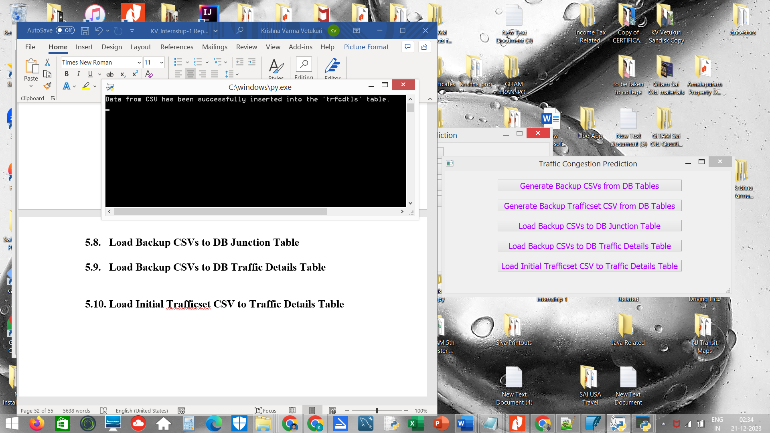

**Figure 31. Load Initial Trafficset CSV to Traffic Details Table**

**CHAPTER 6: CONCLUSION AND FUTURE SCOPE**

**CONCLUSION**

This project entitled **“Traffic Congestion Prediction using Deep Learning.”**is useful for traffic controlling department in diverting the traffic through signals with less traffic.

The project is useful to the road travellers to reduce their travel time by avoiding the signal congestions.

This project finally leads to the improvement of quality of road travel.

**FUTURE SCOPE**

As of now, the system is implemented by using Bi-Directional LSTM. It can be further extended by considering recurrent neural networks like **GRU.**

**CHAPTER 7: REFERENCES**

[1] TIANRUI ZHANG, JIANAN XU, SIRUI CONG, CHUANSHENG QU AND WEIBO ZHAO: A Hybrid Method of Traffic Congestion Prediction and Control, IEEE Access

[2] SIYUN FENG, JIASHUANG HUANG, QINQIN SHEN, QUAN SHI (Member, IEEE) AND ZHENQUAN SHI: A Hybrid Model Integrating Local and Global Spatial Correlation for Traffic Prediction, IEEE Access

[3] BASHARAT HUSSAIN, MUHAMMAD KHALIL AFZA (Senior Member, IEEE), SHAFIQ AHMAD AND ALMETWALLY M. MOSTAFA: Intelligent Traffic Flow Prediction Using Optimized GRU Model, IEEE Access

[4] X. Zheng, W. Chen, P. Wang, D. Shen, S. Chen, X. Wang, Q. Zhang, and L. Yang, "Big data for social transportation," IEEE Trans. Intell. Transp. Syst., vol. 17, no. 3, pp. 620-630.

[5] https://www.python.org/

[6] https://github.com/baoboa/pyqt5/blob/master/pyuic/uic/pyuic.py

[7] <https://www.numpy.org/>

[8] <https://riverbankcomputing.com/software/pyqt/intro>